Agricultural Needs and Assets Assessment
Preliminary Assessment of Bareti in Tsalka Municipality, Georgia
Abigail Edwards
UC Davis- Blum Fellow for Environment and Development
Table of Contents
- Background ……………………………………………………………………………………………………………………… 3
  - Project Background
  - Regional Background
  - Country Agricultural Background
- Agricultural Resources and Assets …..……………..………………………………………………………………………..…… 6
  - Educational Knowledge
  - Experiential Knowledge
  - Technological and Resource Uses and Limitations
  - Land Use
  - Labor
  - Photos of Popular Land Use
- Commercial Agriculture.…………..………..……………………………………………………………….…………………… 11
  - Products
  - Potato Production
  - Production Techniques
  - Results and Analysis
- Personal/Family Agriculture ……..…………..……………..……………………………………………….…………………… 13
  - Techniques
  - Results and Analysis
- Development & Capacity ……...…………..……………..……………………………………………….…………………… 15
  - Development Priorities
  - Development Capacity
  - Critical Responses
- Conclusion & Next Steps ……...…………..………..……………………………………………………….…………………… 18
  - Recommendations
  - Next Steps

- Background
  - Project Background
2017 Report: A community needs and assets assessment of Bareti and Sabechisi was conducted for the Bediani Children’s Center (BCC) in 2017 by UC Davis RIFA Fellow, Bilkis Bharucha. The goal of this assessment was to collect information on the needs and available resources in these villages, identify any direct impact of the farm’s water use, and to make recommendations for long-term farm planning based on community needs. Following this report, it was determined that a community needs and assets assessment of Bareti should be conducted with special attention to Agricultural resources and needs.

2018 Report: In August 2018, an agricultural needs and capacity assessment of Bareti was conducted for BCC and other partners to collect information on the needs and available agricultural resources, education, and capacity in these villages, and to make recommendations for long-term farm planning based on community needs. We first interviewed the village mayor who facilitated our household interviews with individual farmers. Ten farmers were interviewed who were selected by the mayor of the village to represent a variety of ages, affluence, and land size. Farmers were interviewed with both general agricultural technique questions and specific interest questions about potato production (See Appendix A).

2018 Workshops: In August 2018, three days of intensive sustainable agriculture workshops were provided to villagers in Bareti. Attendees were taught basic concepts in soil science, plant nutrient management, irrigation, and general potato farming techniques with the overall focus on potato production. The workshops emphasized the utilization of cost-effective materials and approaches to reduce both soil degradation and dependence on synthetic nutrient and pest management methods. Observations from the workshops are also included in this report.

  - Regional Background
Climate and Demographics: The Tsalka municipality is located in the Kvemo-Kartli region known in Georgia for its fertile soil, access to water resources, and the potential for development of agriculture. This region is also in one of the most ethnically diverse municipalities in the region. In the early 1990’s, following the collapse of the Soviet Union, Tsalka was facing a number of socio-economic development challenges related to the migration of the local Greek population returning to Greece resulting in the abandonment of buildings and property ownership issues. This later caused property ownership conflicts between immigrants resulting from poor land management. Later, the region received an influx of ecological migrants during 2000-2008 from mountainous regions of Georgia (Svaneti and Adjara) that were affected by natural disasters such as landslides, floods, mudflows, etc. Bareti is located about 30 minutes by car from Tsalka, the largest city in the municipality. Bareti is at 1,620 meters (5314 feet) altitude and has a farming season from mid-May to late-August/mid-September.

Potato Production: The Kvemo-Kartli region grows approximately 20% of Georgia’s potatoes, the second largest region in potato production. Due to climactic and dietary reasons, almost every family in Bareti farms potatoes. Some farmers grow large quantities of potatoes for production while others grow potatoes in their home gardens to feed their families through the year. A 2017 market analysis report indicates that the average potato production in the Kvemo-Kartli region is 10.83 tons per hectare whereas the average for developed countries is 40-60 tons per hectare.
Figure 1: Average productivity of potato per region (ton/hectare)
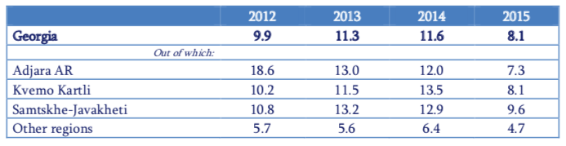
Source: Potato Market Analysis Report

  - Country Agricultural Background
Production and Labor: Because of Georgia’s favorable conditions for agriculture, 43.3% (over 3 million hectares) of the country of Georgia is classified as agricultural land (this includes pasture land and meadows used for hay production). Agriculture accounts for approximately 52% of the country’s labor force, with the vast majority being individuals who inhabit small villages in rural areas due to the lack of other employment opportunities. Although over half of the population farms for a living, the average annual salary of a farmworker amounts to only 64% of the national average (2013).

Imports and Exports: Georgia imports significantly more agricultural products than are exported. This has resulted in a major source of economic loss due to the low production rates. In 2014, Georgia signed an agreement (the Deep and Comprehensive Trade Area) with the European Union (EU) which opened the EU market to Georgian agricultural goods. This has resulted in an increase of the exportation of Georgian agricultural goods by 19%.

Figure 2: Georgia’s Agricultural Trade (2005-2013, in million USD)

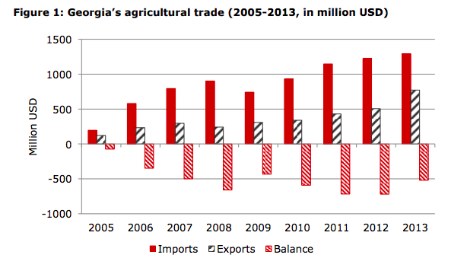
Source: Ministry of Finance of Georgia

- Agricultural Resources and Assets
  - Educational Knowledge
Formal Education: Farmers with education specific to agriculture is very rare in Bareti. Only two of the farmers interviewed stated that they had attended some type of formal agricultural education, but this was limited to vocational trainings. Some farmers had attended and graduated high school but none had attended any form of university or higher education. Six of the farmers had attended various workshops and trainings in the area. The majority of the trainings that farmers attended were facilitated by the Bediani Children’s Center which they traveled two hours to and from Bediani to attend. Those who had attended the trainings found them useful; however, they lacked the funding to apply what they had learned in the trainings. One farmer who was more knowledgeable about fertilizer cited having attended trainings conducted by an organization called CTC on cooperative farming, potato production, and fertilizer. CTC also provided this farmer with potato seeds, beet seeds that were specially used for cow feed, and assistance purchasing fertilizer. Another farmer explained that he attended trainings led by another organization called CARE who financed workshops and development projects.

Technical Education and Knowledge: Questions asked during the workshops revealed that many of the farmers lacked basic technical agricultural knowledge. Farmers do not know what different nutrients such as Nitrogen, Potassium and Phosphorous (the three most essential plant nutrients) provide to their crops. For information on pesticide and fertilizer use, farmers rely on Agronomists or other experts in the area, with the general practice of purchasing as much fertilizer as they have money to purchase regardless of plant needs or soil nutrient content. Prior to the 2018 workshops, no soil tests had been conducted on the majority of farms in Bareti leading to poor nutrient management. Additionally, farmers have limited knowledge of plant needs as it relates to nutrient and fertilizer management and application resulting in fertilizer application only during the beginning of the season which can lead to nutrient loss due to varying plant needs throughout the plant life cycle.

Sustainable Agriculture: Sustainable agriculture is the practice of using farming methods that are holistically beneficial and can be continued indefinitely with minimal burden on the environment, i.e. abstaining from the use of synthetic pesticides, returning organic matter to the soil, etc. When asked if the farmers knew what sustainable agriculture is, five farmers responded that they either knew what it entails, or they had heard of the concept in the past. When asked to explain what they think it means, the majority interpreted it as the ability to get large amounts of capital from one’s farm and are well educated to solve agriculture related problems. Five of the farmers interviewed were not familiar with the concept.

Problem-Solving: Since very few farmers have had access to education on plant health and nutrient management, they rely on other “experts” to recommend solutions. For plant nutrient management, farmers either take advice from the store they are purchasing the fertilizer from, an agronomist in the area, or other farmers. When they encounter a pest or disease affecting their crop, farmers source information from various outlets. They can consult other farmers in the area who have no formal training, go to an agronomist in the area who is in high demand, ask the pesticide seller which they recommend, or pay to take a sample into the capital city of Tiblisi to have experts from the Ministry of Agriculture examine and recommend a solution. Each option has varying degrees of risks and/or costs.

  - Experiential Knowledge
Every farmer interviewed had migrated to Bareti in the early 2000s. 9 out of 10 farmers had migrated from the mountainous area of Svaneti, and one who was native to Tsalka but had moved to Bareti 5 years ago. Many farmers rely on knowledge from the village elders in addition what they had practiced in their place of origin which is geographically very different than Bareti. Farmers exchange knowledge about practices either from personal experience or heard second hand that had either resulted in success or failure. Because these experiences are case specific and often anecdotal, they possess no scientific proof and sometimes directly contradict published agricultural best management practices. Alternatively, some farmers have observed common agricultural phenomena but lack the basic education to understand the underlying science behind the concepts; and as a result, the farmers have no knowledge as to how to use these tools to their benefit.

  - Technological and Resource Uses and Limitations
Water: Most farmers indicated that they did not irrigate their fields because of the high cost of irrigation equipment (~ 1,000 GEL/ha/year). The only form of irrigation we were shown was the village head’s system (See figures 3-6). This system is dependent on an open water source where water is siphoned into irrigation pipes using a gas powered, portable generator. The pipes connect to sprinkler heads that then distribute the water evenly across the farmland. This is a movable system, well suited for this area but because of financial constraints, this system is rare in Bareti.

Images 1-4: Top left – portable irrigation pipes used to move water from the source to the fields and attach to sprinkler heads. Top right – sprinklers used to attach to the pipes. Bottom left – village head showing us how the sprinklers connect to the pipes. Bottom right – gas powered pump attached to a tractor; the pipe rising from the pump is lowered into the water source which is then forced through the pipes.
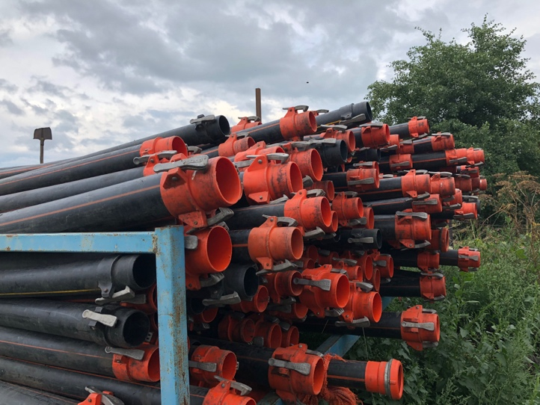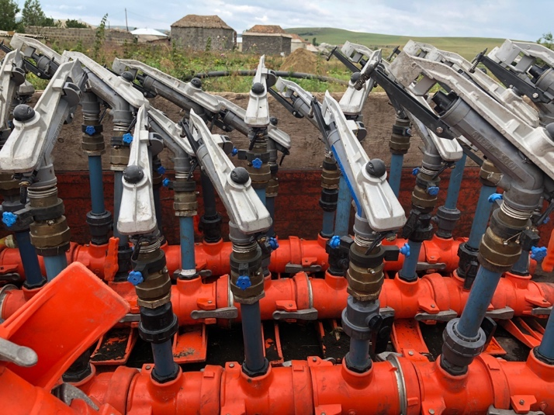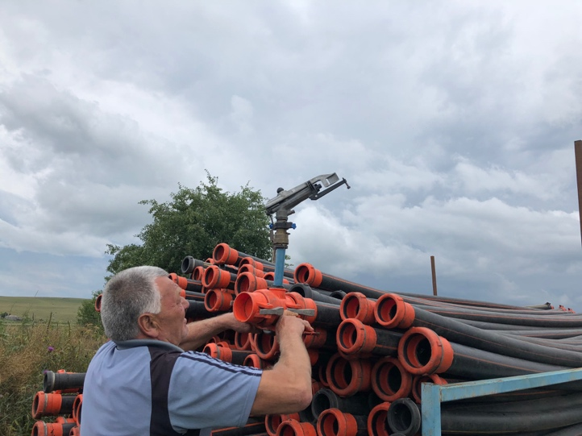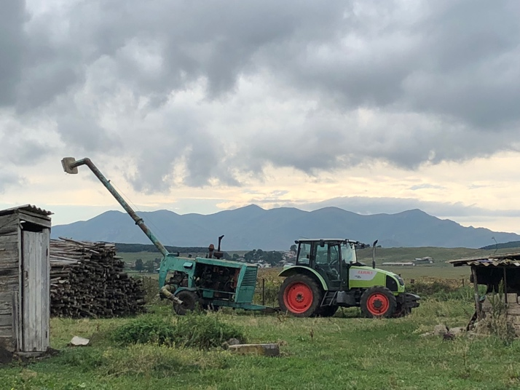

Machinery: “There are ten tractors in Tsalka municipality and 2-3 tractors in Bareti, owned by families who provide the service of plowing or tilling for 120-180 GEL/ha.” It is difficult for some farmers to get access to the machinery because of the high demand during peak farming times (planting and harvesting). Farmers who do not own their own tractor and have difficulty affording the heightened rental cost must wait later than usual to plant, harvest, and plow their land. “Some farmers add themselves to a list for using the local tractor, while others rent from neighboring villages. Another popular option is for farmers to pool money in a bank and request a tractor from the ministry of agriculture, which is cheaper (100-120 GEL/ha) compared to the village tractors, and also has the appropriate 30 cm tooth wheel which is necessary for tilling.”
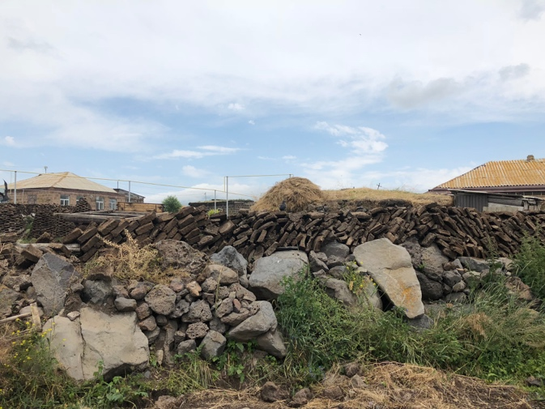
Manure: Families who have no funding for alternative fuel sources burn cow manure that is dried and cut into blocks and used for heat during the winter (See Figure 7). Some farmers use small amounts of manure on their farm or garden. The farmers who use manure either apply in the spring or fall. One farmer interviewed recalled that some village elders suggested that it is better to apply manure in the fall, but had no indication as to why. Farmers who do use manure apply raw manure that has not been composted and is exposed to the elements which then risks creating a host for pests. Others in the village let manure pile on their land with no use. When asked what he does with his manure, the village head said he would pay people to take it away.

Image 5: Blocks of cow manure stored on top of a fence.

  - Land and Management
Land distribution: “Families who migrated to Tsalka Municipality received land under two different land redistribution schemes between 2006-2012. Although this land was “gifted” to families, the ownership does not extend to any development or sale of the land.” Most of the farmers interviewed cultivated 1-3 hectares yearly with one who farmed 8 hectares, another farmed 12 hectares, and the village head farming on 40 hectares.

Land Use: Land for commercial agriculture is used to grow hay, potatoes, and cereal grains. Areas used for potatoes or grain is intensively managed and cultivated whereas land used for hay requires less management because wild seeds are used. Every family has a small garden located close to the home. Almost every family has at least one cow, with those who are in the cattle business (mostly cheese and milk production) owning larger herds. For families with cattle for personal use, some land (usually near the home) is partitioned for cattle grazing for families who own cattle and farm other products.

Management: Some of the farmers recognized the importance of crop rotation (the practice of rotating crops on different land to reduce the risk of disease and pests as well as manage nutrients) but most were not able to explain why this was important. Each family farm that is used for commercial agriculture is usually managed by the male head, which could be the eldest male or the most capable man in the family such as a son or son-in-law. Family gardens are mostly managed and cared for by the women of the and/or the retired men household.

2.5 Labor
None of the farmers interviewed contracted for labor. They instead rely on their families during the peak seasons (planting and harvest). Family members usually included both husband and wife as well as children and sometimes extended family. In general, there is more work available for both men and women during mid-spring, summer, and fall (April-October), especially during the hay and potato harvest. There is typically less work available during winter and early spring (November-March) with the exception of caring for cattle, which is a year-round activity.

- Commercial Agriculture
  - Products
The top-three marketed products are potatoes, cheese, and heifers. The top-three products by cultivated land are potatoes, wheat/barley, and hay. Grains are cultivated mostly in small amounts for animal (cattle, duck, and chicken) feed and household consumption. Cattle are mostly raised for milk and cheese production.
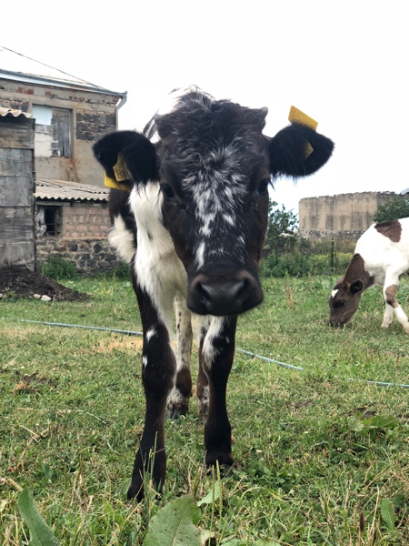
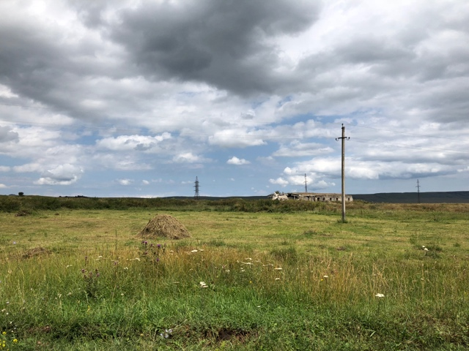
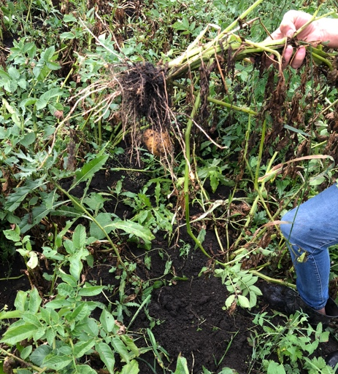
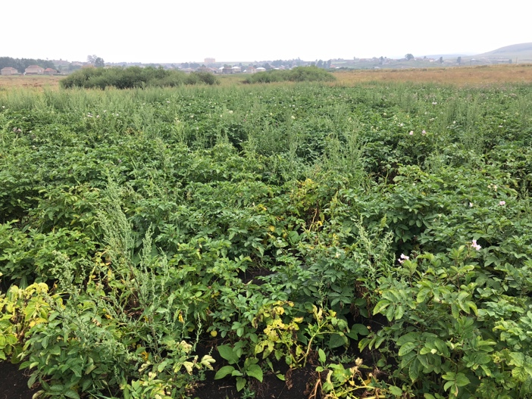
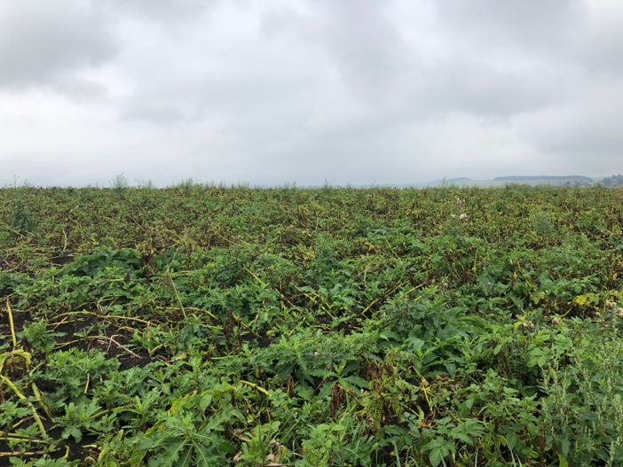
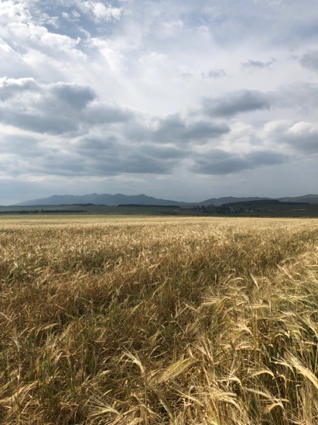
Images 6-11: Photos of popular commercial agriculture – barley, potato, hay, and cattle production.

  - Potato Production
Most farmers grow potatoes to sell comercially as well as for personal use. The land is typically plowed in spring before planting and/or during the fall after harvest. If it is deemed that the land has not been broken up enough by the plow, an implement is used to break the soil into smaller aggregates. Some farmers plow the residual plant matter into the soil to decompose over the winter, others opt to remove the leftover potato plants and leave them in piles to dispose of them. One farmer burns the potato plants on the surface of the soil after harvest. Potatoes are mostly mechanically planted in the spring after the last frost using an implement that digs a furrow, plants the potato, then covers the seeds. Fertilizer is distributed on the land using a tractor and implements and is either added before or immediately after planting, depending on what form the fertilizer is in and what implements are available. Potatoes are mostly farmed without irrigation, farmers rely on spring rains after the initial planting and infrequent summer rain showers throughout the growing season. Pesticides are applied mechanically and as needed throughout the season. In August/September, potatoes are harvested using an implement that brings the potatoes to the surface of the soil. The potatoes are then removed by hand. Potatoes are stored for up to one year in root cellars, the first floor of the home, or in a hole dug into the ground. They are then “marketed either in Tbilisi, Marneuli, or for local pickup in Bareti for 50-80 tetri/kg.” Seed potatoes are stored in the same method for the next year’s crop.

Yeild: The average annual yeild for interviewed farmers was around 10-12 tons/hectare. One farmer recalled an Armenian farmer who had once produced 40 tons/hectare, the highest they had heard of in the area. Most farmers start with higher yeilds – between 20 and 35 ton/hectare – the year after they purchase and use new seed, then experience a decrease of about 5 ton/hectare each following year until this yeild plateaus at around 10 ton/hectare.

Seed: The smallest potatoes of the crop are selected to keep for seed. Seeds are stored in root cellars until they are removed for a brief period to grow sprouts before planting. If the sprouts grow longer than an inch, they pick them off, allow the seed potatoes to re-sprout, and repeat the processes until it is time to plant. Most farmers have little knowledge of what type of seed they use. If the farmer knows the variety of seed, the only information they have about what traits the seeds have is from either what they were told by sellers or from what other farmers with similar seeds had experienced. There is little to no access to the full breadth of knowledge that should be provided when purchasing seed such as resistance to disease, yeild, and other traits. The two farmers who knew the variety of seed use the Jelly variety which they have been told is capable of growing with low water. Low yeild in this area could be corelated to seed degeneration resulting from improper selection, storage, and treatment.

  - Production Techniques
Every farmer interviewed uses synthetic fertilizers and synthetic pesticides on commercial plots. With the exception of families with low funds and/or small amounts of land, farmers use machinery to cultivate their land. Hay is often mowed with a tractor or, in some cases, a string trimer, and is then dried, turned, and piled using rakes and pitchforks. Barley, wheat, and other cereal grains are seeded, fertilized, and harvested using tractors and implements. The common method of grain harvest is by a columbine. Cattle are herded to and from pasture land by family members each morning and night. All plots are farmed using monocropping with no natural borders.

  - Soil Test Results
Methodology: During the workshops, the farmers had the opportunity to bring a sample of soil to be tested by trained experts using a LaMotte soil test kit. Soil was tested for pH, and Nitrogen, Phosphorous, and Potassium content. It is important to note that the testing occurred at the end of the cropping season so it can be assumed that the majority of the fertilizer applied earlier in the season was either used by the plant or leached out of the soil; however, results could be influenced by residual fertilizer.

Results and Analysis: Overall, soil samples from commercial farm sites had slightly basic to neutral pH, trace Nitrogen, low Phosphorous, and trace Potassium, meaning that the soil had low nutrient value. Low nutrient levels could be due to the high clay content in the soil, yearly removal of organic matter without replenishment, dependence on and high leach rates of synthetic fertilizers, and/or many other causes.

- Family Gardens
  - Products
Each family had a plot of land allocated (usually close to the home) for a family garden. Family gardens produce the majority of what villagers consume and preserve through the year. Products grown vary from family to family. Common crops grown in family gardens include potatoes, herbs, garlic, onions, beets, cabbages, beans, cucumbers, tomatoes, maize, and cabbage.

Images 12-14: Photos of small home gardens.
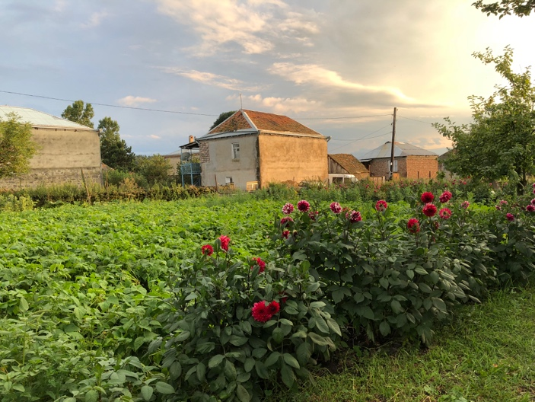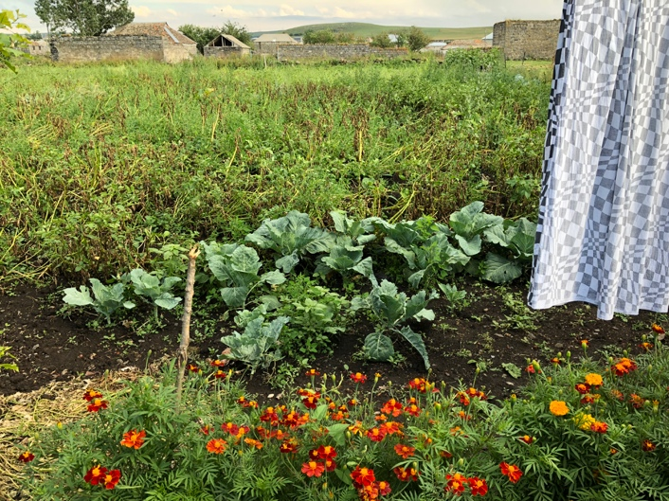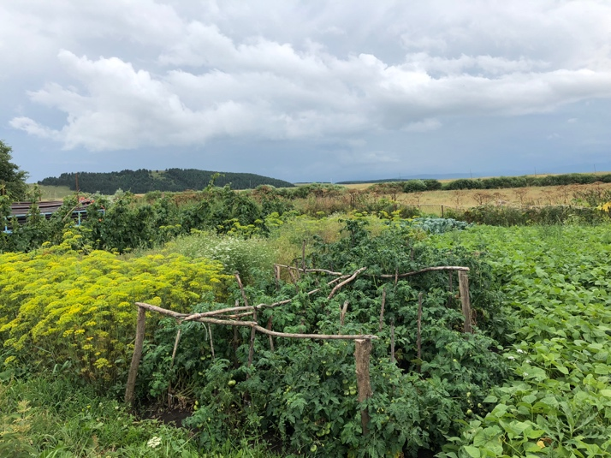

  - Production Techniques
Most family gardens do not use synthetic fertilizers and pesticides because of the high price. One farmer said that she did not use synthetic fertilizers and pesticides on her garden because she said she had been told chemicals are unhealthy. Some farmers used manure on their family gardens. Most gardens are planted using intercropping and many have some form of a natural border.

  - Soil Test Results
Methodology: Farmers tested soil samples from their home gardens. The same methodology and materials were used as in the commercial agriculture soil tests.

Results and Analysis: Overall, soil samples from the family gardens had slightly acidic to neutral pH, medium Nitrogen, high Phosphorous, and medium Potassium, meaning that the soil had much higher nutrient value than the commercial plots. Higher nutrient levels could be due to the return of organic matter to the soil in the form of manure, less dependence on synthetic fertilizer, less intensive farming techniques, and/or many other causes.

- Development & Capacity
  - Development Priorities
Capital: One of the central problems identified by farmers was the lack of sufficient capital to improve their farms. Farmers who had attended agriculture workshops in the past explained that the knowledge that was shared is inaccessible to them due to a lack of funds. Often the solutions presented to the farmers are not affordable to them. The lack of funds also leads to the perpetuation of poverty in this area. One of the farmers explained that their farm sometimes only produced enough potatoes for seed for the following year, but very little additional tubers to sell or consume.

Seeds: Seed degeneration was a key problem for most farmers. Farmers expect their seed to produce high yield in the first year of planting, then decrease by 5 tons/hectare each year, eventually leveling at around 10 ton/hectare. The vast majority of farmers store their seed potatoes in an underground cellar or a simple hole dug into the ground. These areas are not temperature and humidity regulated. Fluctuations in temperature due to seasonal changes can lead to a loss in the viability of potato seed. The lack of controlled humidity in storage areas can lead to seed rot should the humidity be too high, or excess drying if the humidity is too low. Education on proper seed selection is also needed. Farmers selected the smallest of the potatoes to carry through to the next year as seeds and reserved the larger potatoes for market to maximize revenue. This poses a significant problem because smaller seeds can spoil faster and may not be able to supply enough energy to the growing plant. Additionally, because potato plants are clones of the seed, smaller seeds can lead to the production of smaller potatoes. The lack of education of proper seed selection and storage is a contributing factor to seed degeneration. Improper chitting and cutting of seeds due to a lack of education is also a concern. Farmers lack the understanding that the flesh of the potato is necessary for potato growth and immediately discard of the center of the potato after cutting and planting just the sprouts. When combined, these practices result in much lower yield thus less income for the farmers, making it nearly impossible to purchase new seed.

Roads: Another issue, as highlighted in the previous report, is the lack of a paved road. “The lack of a paved road increases the amount of time required in traveling for work or to markets in Tbilisi, accessing foods (via the mobile market) and limits accessibility to farms that might be located far from their house, among other things.” If conditions are poor during the winter, the village can become completely inaccessible stifling farmers’ ability to access markets to sell their goods throughout the year. The lack of economic activity in the village may be a disincentive for the development of roads.

Images 17-20: Roads in and around Bareti.

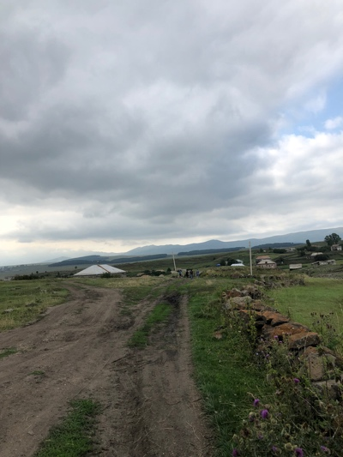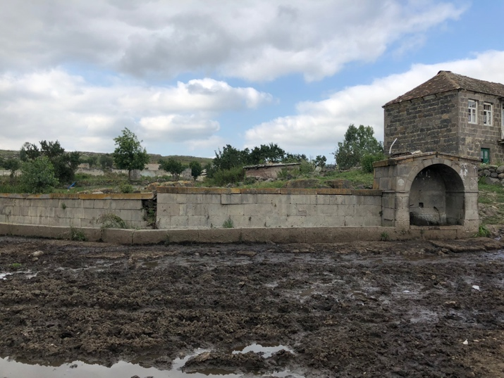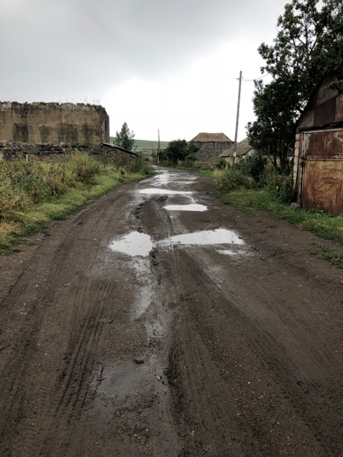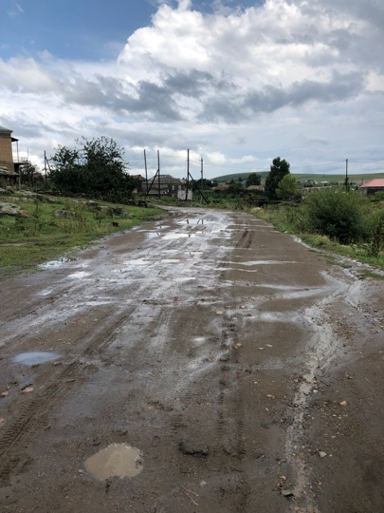

Land: Limited quantity and quality of farm land, as well as limited pasture land was a key problem for most families interviewed in both assessments. This may be due to greater interest in expansion from families with larger farms, as well as the dependence of the village on land for income.
Specific issues related to land include the soil characteristics, access to farm land, and soil fertility. Soil in Bareti is high in clay, which is described to behave like cement during the dry parts of the year is virtually unworkable when dry. Because of its high cation exchange capacity, the clayey soil also limits plant ability to access the nutrients in the soil. Without the constant input of large amounts of organic matter, the land is very inhospitable to plants meaning that farmers must spend much of their earnings from the previous year on fertilizers. In addition, much of the available farm land is located far from the central town and access roads to this land are either in poor condition or nonexistent.
Some families indicated land insecurity as a concern because they do not hold titles to the land they farm on. When asked how much land they farmed on, some farmers explained that they used both land that they legally owned and land that they did not hold titles for. This can be a result of the utilization of unused government-owned land, the financial capacity for farmers to purchase additional land, or a lack of interest from the owner to sell the land.

Machinery: The lack of access to and affordability of different types of machinery is a severe problem for farmers. Farmers with less land and less available funds are often unable to plant, harvest, and plow at the correct times because of the low numbers and high price of machinery. Although some farmers emphasized their ability to fix machines, many farmers were displeased with the quality and capacity of the machinery available because of frequent breaking and a lack of access to some specialized implements.

Irrigation Access: Farmers acknowledged the benefits of irrigation, but few lacked sufficient funding to irrigate their crops. Many recognize the presence of hollow heart in their potato crop, a key indication of fluctuations in the water supply. Hollow heart is a concern because it renders their potatoes not viable for sale. Most farm land is far from usable water sources meaning that the farmers would need to pay and maintain a water pump in addition to standard irrigation supplies.

  - Development Capacity
Infrastructure: The Bediani Children’s Center plans to construct a potato storage facility which could impact the way that farmers store their seeds and crop. “The government has plans to develop a paved road through both of these village, which could have a large impact on the capacity of the communities to travel more regularly between villages and to Tbilisi, bringing more economic development.”

Social Capacity: Every farmer interviewed expressed an interest in workshops. The key to successful workshops will be in providing farmers with affordable solutions or methods and techniques that have either a positive economic outcome or have no cost. An important factor of success for workshops will hinge on the timing of the workshops in consideration of important farming dates as well as inhospitable weather conditions. The recently renovated school could serve as a space to hold more agriculture workshops. Farmers at the initial workshops were highly engaged and receptive of the concepts covered.

  - Critical Responses
We interviewed one farmer who had a critical response to the capacity for irrigation development in Bareti. CARE was an organization that had been present in Bareti and worked on development projects, such as the community drinking water station, and facilitated workshops for the village. This farmer was the director of CARE in Bareti. The farmer explained that CARE was interested in funding a project that would provide irrigation infrastructure to farms in Bareti. The arrangement was that the organization would fund 75% of the project as long as the farmers provided 25% of the funding through manual labor. The project was unsuccessful because the villagers were not interested in contributing labor. This response is compounded by the responses articulated in the previous report surrounding concerns by interviewees that “there was little scope for development through agriculture in the village due to the lack of infrastructure (roads, market access, land quality) and the local climate (long winters, hail during the growing season).”

- Conclusion & Next Steps
  - Recommendations
For long-term development, village leadership interested in agriculture should be identified and interviewed by parties involved in development projects to set priorities for the village. The first step could be through townhalls and/or roundtable discussions open to the community. Following initial community forums, village leadership could be contacted to create a small taskforce to be involved in development priorities and needs as well as to publicize and mobilize the community to attend workshops, events, trainings, etc. In the interviews and workshops, a core group of women were particularly interested in the project. These individuals might be valuable assets to future project success. By creating this working group, development agencies can gain important insights into the needs and interests of the village as well as gain local credibility.
The foundational agricultural knowledge is present in the village. What the farmers lack is a deeper understanding of scientific concepts and application on a large scale. For example, during the workshops, a villager explained that she had observed that her crop of carrots always did particularly well following a planting of beans. This occurrence has been scientifically proven, but the villager lacked the understanding that the beans are in the legume family which fixes nitrogen in the soil so any crop following beans would have a higher yield. Those who have access to this knowledge can then apply these concepts to large-scale agriculture in the form of legume cover crops. Yet without this educational component, villagers are left with the anecdotal reasoning for the positive and negative effects of some practices and no way to apply these concepts to a larger scale or expand the realm of possibilities.
In the post-evaluation administered at the end of the trainings, every attendee responded with their interest in more workshops. Given that the villagers are familiar with some agricultural concepts, and are interested in furthering their understanding, it would be beneficial to bring experts from around Georgia to deliver topic-specific workshops. There should be particular emphasis on low-cost solutions and/or education on how to improve practices that are still in place; trainings on fertilizer use and application, pesticide use and application, and pest/disease identification would be particularly useful in this respect. Farmers that were interviewed as well as farmers who attended the workshops are interested in trainings on cow husbandry, plant pathology, fertilizer use and purchase, composting, and manure use. There was a very high interest in cattle, this may be a good topic for the next workshop that is offered.
Speakers should be familiar with the environmental and socio-economic backgrounds of the village to deliver practical and applicable materials.
The Bareti farm development project can be a leader in sustainable agricultural development by testing various methods and crops, introducing localized solutions for improving productivity of existing crops, and developing access to new markets. It is possible to grow a variety of cold-weather crops (such as legumes and brassicas) in Bareti, yet these are only grown for personal consumption. By testing not only growing alternate crops but finding an avenue to market and sell these crops, the Bareti farm development project can demonstrate the financial feasibility of diversifying farms.
In the interview process and workshops, it became clear that most farmers are unwilling to try a new method or crop unless they have seen it prove successful in the area first. This is likely due to their status as subsistence farmers with little disposable capital. Farmers are less likely to invest in a practice or crop that has the potential for high risk because it could prove detrimental to their finances. Because of a hesitancy to test different methods, it will be important to hold two identical trainings, one before a practice is implemented on the Bareti farm development project, and a similar training after the practice has been successful. This will allow villagers to learn about and become familiar with the concept, then see it in practice, and if it is successful, villagers can have another opportunity to learn more in depth, so they can implement it on their own farm. The Bareti farm development project can be a key component in lowering the perceived risk of sustainable practices leading to further implementation.
Timing of the workshops will be key to their success. It will be advantageous for workshops to be held in the winter when farming is not a main activity. It will also be in the best interest of development agencies to reach out to the community to identify a time that is best for interested villagers. We found that it was best to hold workshops when it was raining outside because no work could be done on the farms. We also found that the best time for villagers was to begin sometime in the afternoon after lunch (1:00pm/3:00pm) and end before the cattle was herded at night (5:00pm/6:00pm). Workshops that provided some type of service were the most popular. The day we administered soil tests was the most popular.

  - Next Steps
The agricultural assessment remains incomplete until there is a follow-up village meeting (particularly with farmers who were interviewed and those who attended the workshops). A follow-up meeting with villagers and development agencies can demonstrate the long-term interest and investment of the Bareti farm development project and the associated stakeholders. The meeting could also identify individuals interested and willing to advocate on behalf of the agricultural and development needs of the community. Furthermore, a well-developed crop and management plan should be co-created by the stakeholders of the farm to solidify the purpose and end goals of the farm.
Also, since the general vision of the farm is to be both a productive farm as well as an educational site that provides both practical and theoretical learning for local farmers, it will be necessary to prepare a foundation for future trainings in organic/bio and sustainable agriculture by building a relationship with the local community and by demonstrating these concepts through successful projects on the farm. Farmers will be more receptive to new ideas if they have already seen successes on the farm and are aware of the farm’s interest in local development.

Over the next month:
- Meet with prominent Bareti leadership to develop a working relationship and establish development priorities.
- Begin planning workshops on cattle farming, composting, and pest/disease identification.
- Draft a co-created mission statement for the Bareti farm development project.
- Identify farming priorities and goals for the Bareti farm development project.

Over the next year:
- Develop a long-range plan for the Bareti farm development project’s involvement in the community.
- Conduct a more in-depth agricultural needs assessment by an in-country agency to compile data and identify the most pressing development challenges. This will also show continued interest in the community.
- Involve all stakeholders and partners in the drafting of an in-depth land and crop management plan keeping the identified priorities and goals at the forefront of this process.
- Hire a person from Bareti to manage the farm site. Specific skills should include an in-depth knowledge of potatoes, and ability to use and operate machinery.
- Begin to test different colored potatoes and save seed for the next year. Explore feasible avenues through which farmers can sell these potatoes at a higher cost.
- Begin to test other crops on a larger scale and identify feasible methods of sale.

Appendix A: Questions from the 2018 Bareti Agriculture Needs and Capacity Assessment interviews.

Objective: to understand and collect data on how farmers in Bareti farm their crops for future workshops and grants.

- How big is your farmland (in hectares)?
- Do you cultivate it every year?
- For how long are you farming and where (in Bareti or other place in Georgia)?
- How many people are involved in your farm activities?
- Do you have any agricultural knowledge from University or VET institution?
- Where do you get advice when you have problem in your farm?
- Did you got any knowledge from trainings related to agriculture?
- Did you applied knowledge from training in your farm?
- What do you farm to sell?
  - If potatoes, what seed potatoes do you use?
- What do you farm to eat for personal use?
- How often do you plow during the year and when?
- What kind of plowing activities do you apply on your farmland?
- Do you use fertilizers?
- If yes, What kind of fertilizers do you use?
- Do you irrigate? If so, how, when and how many times?
- What do you do to control pests and diseases?
- What do you do with the plants when they are done producing?
- Are you familiar with sustainable agriculture, what do you think it means?
- Are you interested in attending potato and agriculture workshops?
    - If yes, what are you interested in being covered?
    - If yes, what time would you prefer the workshops to be?

http://enpard.ge/en/wp-content/uploads/2015/05/Potato-Market-Analysis-Report.pdf
http://enpard.ge/en/wp-content/uploads/2015/05/Potato-Market-Analysis-Report.pdf
http://enpard.ge/en/wp-content/uploads/2015/05/Potato-Market-Analysis-Report.pdf
http://www.fao.org/georgia/fao-in-georgia/georgia-at-a-glance/en/
http://www.moa.gov.ge/En/ExportImport
MoF (2014). Ministry of Finance of Georgia. Export-import statistics. www.mof.ge. Tbilisi.
Bharucha, Bilkis. 2017 Bareti Community Needs and Assets Assessment.
Bharucha, Bilkis. 2017 Bareti Community Needs and Assets Assessment.
Bharucha, Bilkis. 2017 Bareti Community Needs and Assets Assessment.
Bharucha, Bilkis. 2017 Bareti Community Needs and Assets Assessment.
Bharucha, Bilkis. 2017 Bareti Community Needs and Assets Assessment.
Bharucha, Bilkis. 2017 Bareti Community Needs and Assets Assessment.
https://vric.ucdavis.edu/pdf/organic_potatoes.pdf
Bharucha, Bilkis. 2017 Bareti Community Needs and Assets Assessment.
Bharucha, Bilkis. 2017 Bareti Community Needs and Assets Assessment.
Bharucha, Bilkis. 2017 Bareti Community Needs and Assets Assessment.
Bharucha, Bilkis. 2017 Bareti Community Needs and Assets Assessment.
Bharucha, Bilkis. 2017 Bareti Community Needs and Assets Assessment.

