UC Davis Health Campus Education Building Retrocommissioning
Client: Dan Mendonsa, (Energy Manager, UC Davis Health)
Rhys Davis & Ranjith Narasimhamurthy
Spring 2020 – Path to Zero-Net-Energy
- INTRODUCTION
The UC Davis Health Campus in Sacramento houses the UC Davis Medical Center, the UC Davis School of Medicine and various other clinical and research centers. Spaces such as offices and classrooms typically have regular schedules of occupation and are much easier for identification of energy saving opportunities. On the other hand, hospitals and medical spaces have stricter regulations for lighting and ventilation and addressing energy use is more difficult. As a result, the Education Building at the UC Davis School of Medicine was chosen for an energy audit and retro-commissioning effort.
Retro-commissioning is a process that improves the building equipment and system functions together. This effort was mainly focused on the building’s HVAC (heating, ventilation and air conditioning) systems while lighting systems were also addressed superficially. The purpose of the project was in reducing operating costs and reducing carbon emissions. Equipment failures, control programming resets and potential scheduling changes were addressed to develop the list of Energy Conservation Measures (ECMs). Finally, an action plan was provided for the long-term persistence of the ECMs.
- LITERATURE REVIEW
Literature was reviewed to supplement and provide direction in the retrocommissioning effort. The category of topics that were reviewed can be broadly classified as best practices in classroom buildings, estimation of energy use and savings, and energy conservation measures.
The most effective measures for classroom building retro-commissioning and their implementation were investigated in order to prioritize the Energy Conservation Measures given the large scope and minimal time. NREL produced a roadmap for effective RCx planning and performance implementation including a priority list for consideration of retrofit measures [1]. Common ASHRAE standards for classroom building ventilation and thermal comfort were also looked into [2].
Accurate and robust ways to estimate energy use and savings from the proposed Energy Conservation Measures (ECMs) were identified. This was necessary given the limited time, limited computing resources and spotty energy use data. A study by Mills, et al., provided a meta-analysis of RCx studies with average costs, savings, and ECMs [3]. Fumo, et al., produced a taxonomy of various strategies for energy modeling and savings estimates that was helpful for planning how to approach the project given the data available [4].
Methods to implement control programming resets were studied to determine the optimum choice for maximizing energy savings. Taylor Engineering developed guidelines for efficient pressure and temperature resets that were very helpful for rethinking the way the building air handlers should operate [5] [6].
- METHODOLOGY
  - Energy Profile
The baseline period used for the building energy profile is 4/3/2019 to 4/2/2020, as the project data collection started on 4/3/2020.
Fifteen-minute interval electricity data was procured from the power meter. For the baseline period, data was intermittently available. To fill in the missing data, a model was created using the existing real values starting on 1/1/18 and outdoor air temperature (OAT) at the given timestamp:
$Hourly Electricity Use (kBTU/hr) =415.5 kBTU/hr + OAT×6.4 \frac{kBTU/hr}{F}$
Twenty-minute interval hot water flow and supply and return data was available for the entire baseline period, with the assumption that when the flow was reported as negative, the flow in reality was zero. To determine the energy content of the hot water, the following equation was used:
$Hourly Water Energy Use (kBTU/hr) =(T_{supply}-T_{return})×Flow (GPM)×500.4/1000$
Twenty-minute interval supply and return temperature data was available for the entire baseline period. The flow meter did not provide any usable data, so the flow of CHW to the building had to be estimated by summing the CHW flows for each air handling unit (AHU), fan coil unit (FCU), and air conditioning unit (ACU) at every given time period available; these are assumed to be the only sources of CHW use in the building. The chilled water energy consumption was estimated using the absolute value of the same equation used to estimate hot water energy use.
The model for hourly energy use vs. OAT is shown below. Note that AHUs 1-1 and 2-1 were scheduled starting in December, which accounts for the split on weekdays vs. weekends in the energy vs. time model. The trends show that there is still some HW use during the hotter days, and the CHW use is essentially linear above 65 degrees.
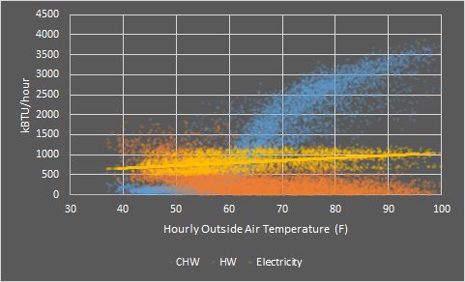
Figure 2: Hourly Energy Use vs. Outside Air Temperature
Using an avoided cost of electricity of $0.08/kWh, an avoided CO₂-equivalent emissions of electricity of 0.090 MT CO₂e/MWh, an avoided cost of hot water of $7.50/MMBtu, an avoided CO₂-equivalent emissions of hot water of 0.053 MT CO₂e/MMBtu, an avoided cost of chilled water of $5.50/MMBtu, and an avoided CO₂-equivalent emissions of chilled water of 0.006 MT CO₂e/MMBtu, the baseline energy costs and emissions were determined in the following table. The building area is 180,423 square feet, which was used to estimate the Energy Use Intensity, a normalized measure of annual building energy use.
Table 4: Baseline Energy Breakdown
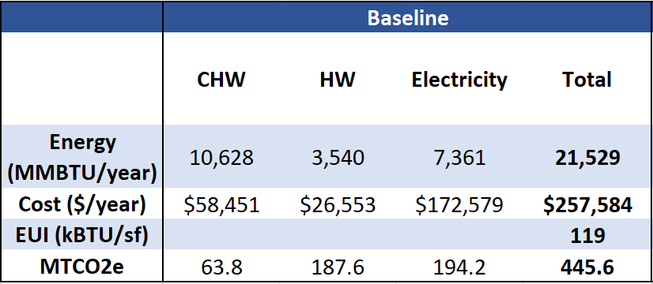
  - Equipment Analysis
Each of the ten AHUs (1-1, 1-2, 2-1, 2-2, 2-3, 3-1, 3-2, 3-3, 4-1, and 4-3) underwent an examination of their schedules, economizer control, minimum outside air flow, CHW and HW valve control, discharge air temperature control, supply fan control, and general programming. Each of the six ACUs and six FCUs underwent an examination of their runtime, temperature settings, discharge air temperature, and CHW valve control. Each of the 225 VAV boxes underwent an examination of their temperature set points, damper control, HW reheat valve control (if applicable), discharge air temperature, and air flow.
  - Lighting
A light count and inventory were not possible for this study, but the lighting schedules were analyzed. Using the ASHRAE 90.1 2007 standard lighting power density (LPD) of 1.2 W/m², or 0.00011 kW/s.f., for university buildings and the areas served by each lighting control zone, we were able to estimate the current annual energy use and potential savings associated with implementing a more aggressive schedule. The calculation for estimating the baseline and post lighting electricity use is shown in the equation below.
$Annual Lighting Energy (kWh/year)=scheduled runtime (hours/years)×LPD (kW/s.f.)×Area (s.f.)$
  - BinSim Tool
To estimate the annual savings of the scheduling, discharge air temperature (DAT) reset, and duct static pressure (DSP) reset for each AHU, we have utilized an Excel tool called BinSim originally constructed by a member of the Energy Conservation Office. The tool uses 2-degree OAT bins populated with hourly data corresponding to frequency from the TMY3 data for Sacramento. After inputting an estimate of the existing schedule, the baseline electricity, CHW, and HW use is estimated for each hour of scheduled use based on equipment specifications obtained from the mechanical schedule for rated maximum CFM and brake horsepower as well as empirical linear models for OAT vs. DAT and minimum and maximum outside air fractions and supply fan output. The post case is determined by estimating the improvements to schedules, DAT reset, and fan output from the various recommendations. A BinSim was performed for each AHU for each AHU recommendation.
  - FCU and ACU Setpoint
Unfortunately, the temperature setpoints of the FCUs and ACUs were not available. To understand the current and potential operation of FCUs and ACUs based on their setpoints, the average zone temperatures over the baseline period were treated as the setpoints, as the units serve server rooms and AV equipment and are programmed to meet the set point 24/7. The units were assumed to be actually running if the unit DAT was at least five degrees less than the zone temperature. With these data points, we could build a linear model of estimated temperature vs. annual unit operation hours. The model is shown below and suggests that for each degree increase in temperature setpoint the unit will run for 211 fewer hours annually. The reality is more complex and most likely not linear, but we deemed it appropriate to estimate the savings of this measure.
$Annual Runtime (hours)=19,685 hours-211(hours/F)×Setpoint (F)$
- RESULTS
  - Equipment Observations
For the recommended reset strategies to work properly, the equipment must first be operating as designed. For the most part, the equipment was in working order. All of the economizers seemed to be working in the way they were programmed, there were no apparent leaking CHW or HW valves, and there were only a few instances of overridden set points or offline or malfunctioning sensors. The main issues stem from minimum outside air dampers not working as intended, maximum and minimum flow settings for VAV boxes being overridden from the original schedule recommendations, miscalibrations. The issues in bold are more critical and strongly recommended to be fixed prior to implementing the temperature or pressure resets.
Table 5: AHU Equipment Issues
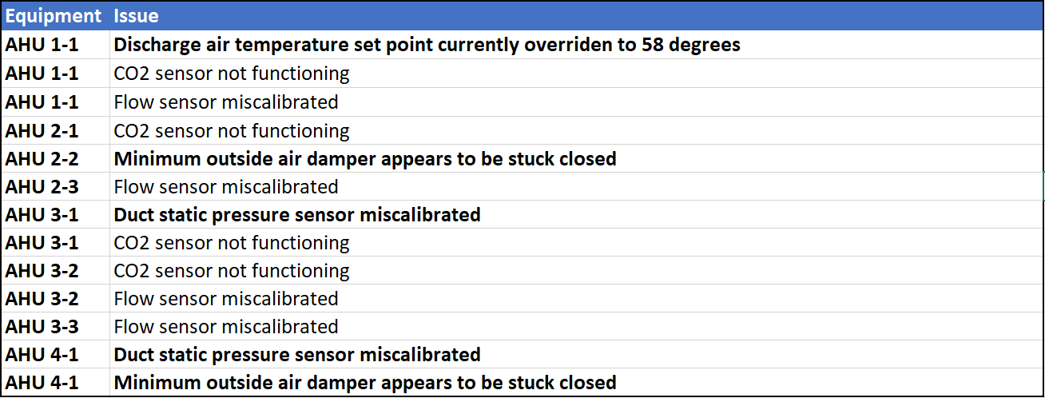
Table 6: VAV Equipment Issues
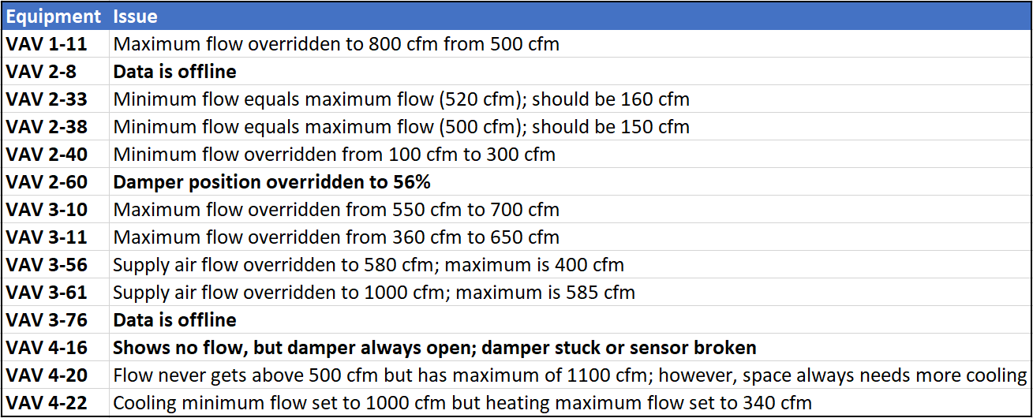
The labor cost for any programming, mechanical, or administrative work is assumed to be $125/hour and $25/hour for any intern work. We assumed it would take 20 hours to address all the issues listed above and that they would all be addressed in order to implement the following recommendations. We assumed the cost of replacing necessary sensors or parts for the damper controls would cost $2,500. As there are no direct savings associated with these measures, only the costs are shown below. They will be included in the scheduling and total payback calculations.
Table 7: Cost of Fixing Equipment Issues
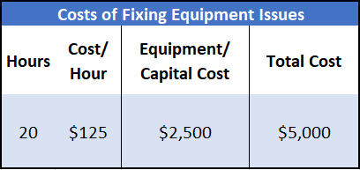
  - Scheduling
The current AHU schedules generally run from 6 am to 1:30 am on the weekdays and 10 am to 2 pm on the weekends, with some variation. AHU 2-2 runs 24/7, as it serves the library. Using the Spring Quarter event schedule provided by the building manager, we determined that the average AHU saw its last event end after 8 pm only 14% of days and after 10 pm only 3% of days. On average, only 23% of weekend days had events. The average event schedule for weekdays vs. the current schedule is shown for each AHU below:
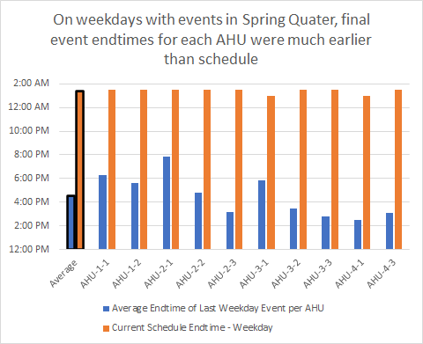
Figure 5: Current Schedule vs. Average AHU Occupiation
Our recommendation is that the AHUs, aside from 2-2, are scheduled based on the schedule provided by the building manager at the start of every quarter. This would require some ongoing work but could be done by an intern at the Energy Conservation Office. A less ideal alternative that would be simpler but provide fewer savings is simply moving the end time for each AHU schedule to 10 pm instead of 1:30 am. The savings were determined using the BinSim model and assume that the average schedule for each AHU is 6am to 8pm and off on the weekends, which we feel is conservative based on the average event end times shown in the graph above. The savings results are shown below:
Table 8: Energy Savings Breakdown of Scheduling AHUs
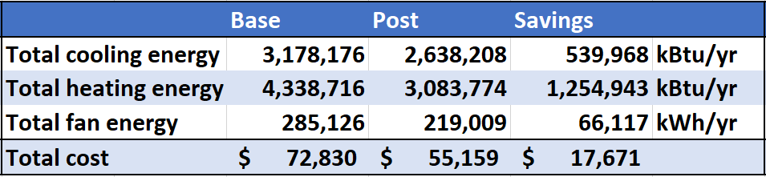
The savings for lighting scheduling were determined using the equation from the Methodology section for Lighting and assumed a similar schedule to that of the AHUs; they are shown below:
Table 9: Energy Savings Breakdown of Scheduling Lighting
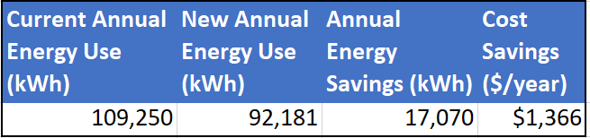
The estimated payback from this measure was determined by assuming the time for initial programming work and working out an agreement to assign the task to an intern as ten hours and assuming the intern takes twelve hours every year to schedule the AHUs and lights. The payback takes into the account the total costs associated with addressing the equipment issues, although not shown in the hours or total cost in the table below. The payback periods for all measures are calculated using the following equation:
$Payback (years)=\frac{Upfront Labor or Capital Costs (\$)}{Estimated Annual Savings (\$/year)-Ongoing Costs(\$/year)}$
Table 10: Payback of Scheduling
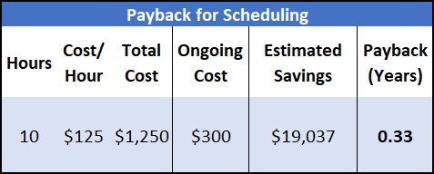
  - Discharge Air Temperature Reset
The current DAT reset is based on the average of four representative zone temperatures. At an average zone temperature of 75F or higher, the DAT setpoint is 55 degrees, and at an average zone temperature of 70F or lower, the DAT setpoint is 65 degrees, scaled linearly in between.
The current VAV setpoints range from 65F to 77F and have deadbands of +/- 0.5 degrees. When these zones have higher setpoints (many are 75F), the AHU makes air closer to 55, which requires the zones to open their HW valves more to maintain the 75F setpoint. We recommend setting all of the setpoints to 72F and adding a deadband of +/- 2 degrees to reduce the frequency of heating and cooling calls, especially if the recommended DAT reset is not implemented.
For a better functioning DAT reset, we recommend using trim and response logic using VAV box cooling PID loop outputs as the inputs for the cooling requests. We recommend using all VAV boxes, not just four representative zones; if just a few are used, it is important that they have somewhat similar and representative setpoints (i.e. one should not be at 75 and the other at 66). The cooling requests are generated when a zone’s cooling PID loop output exceeds 95% and is ignored after it decreases down below 85%. When the number of cooling requests is two or greater, begin decreasing the DAT setpoint by 2 F every 10 minutes until reaching the minimum DAT setpoint or the cooling requests drop below 2. Otherwise, trim the DAT setpoint up by 0.5 F until the maximum DAT SP is reached. See the flowchart below for a better visualization of the logic:
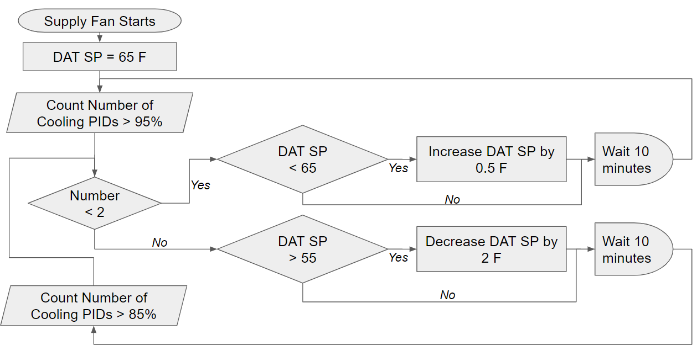
Figure 6: Proposed DAT Reset Logic
The estimated savings from implementing this DAT reset for all ten AHUs were determined with the BinSim tool. Due to limitations in the model, we assumed that the new DAT reset has similar results as a DAT reset that scales from 65F to 55F as OAT increases from 65F to 85F and that the new VAV setpoints were implemented. The base case energy use assumes that the scheduling has already been implemented, as it has a better payback, and it is assumed that there are no electricity savings associated with this measure, only CHW and HW. It is assumed that each AHU and associated VAVs would take three hours to program for a total of 30 hours. The savings and payback are shown below.
Table 11+12: Energy Savings Breakdown from DAT Reset and Payback from DAT Reset
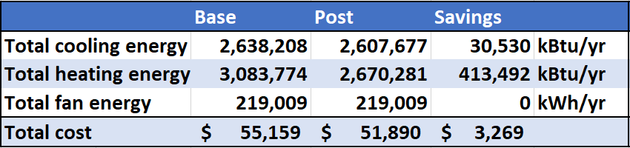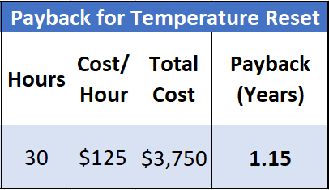

  - Duct Static Pressure Reset
Currently, the AHUs have unchanging DSP setpoints from 0.7 to 1.2 in. w.g. We observed that most VAV dampers were at their minimum positions (unless they had very low temperature setpoints), indicating that the DSP could likely be lowered without significant change in comfort. The best practice here is also trim and response logic, this time using VAV damper position as the input. Again, we recommend using all VAV boxes, not just four representative zones. The requests are generated when a zone’s damper position exceeds 95% and is ignored after it decreases down below 85%. When the number of requests is two or greater, begin increasing the DSP setpoint by 0.15 in. w.g. every 5 minutes until reaching the maximum DSP setpoint or the requests drop below 2. Otherwise, trim the DSP setpoint down by 0.05 in. w.g. until the minimum DSP setpoint is reached. The logic looks similar to that of the DAT reset, but in reverse.
1.2 in. w.g. is the highest current DSP setpoint for any AHU, so it is used as the maximum. 0.2 in. w.g. is used as the minimum value, 0.05 is used as the trim value, and 0.15 in. w.g. is used as the response value based on a conservative interpretation (so as not to risk diminishing thermal comfort) of a recommendation by Taylor Engineering, the company that developed the logic [5] [6].
The BinSim tool was used to estimate savings; the base case energy use assumes that the scheduling and DAT reset measures have been implemented for the AHUs, as they have lower payback periods. Due to limitations in the model, instead of directly accounting for the lower DSP, we assume that a lower minimum fan output would be the result of the reset; the reduction in minimum fan output is assumed to be proportional to the ratio of 0.5 in. w.g. to the current DSP setpoint, which are mostly 1.0 in. w.g. We assume only fan energy savings, not CHW or HW. We think these estimates, although imperfect representations of what the DSP reset accomplishes, are fairly conservative. We assume that the DSP rest will take longer to program and tune than the DAT reset, five hours per AHU. The savings estimates and payback are shown below:
Table 13+14: Energy Savings Breakdown from DSP Reset and Payback from DSP Reset
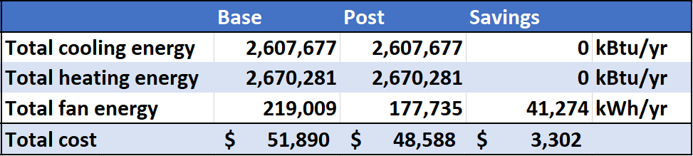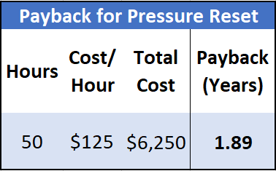
  - FCU and ACU Setpoints
The methodology and equation for estimating the operation savings from changing the temperature setpoints for the FCUs and ACUs was shown in the previous section. Currently, based on our assumptions, the setpoints for the twelve units range from 60F to 75F. ASHRAE 2015 provides a maximum server room temperature recommendation of 80F for critical equipment, with higher allowable levels for most equipment [7]. With this in mind, we recommend raising all temperature setpoints to 78F. The savings of this recommendation are shown below and assume that each unit saves CHW and fan energy from the reduction in operating hours. We assume it takes five hours to manually change the setpoints on all units.
Table 15+16: Energy Savings Breakdown from FCU/ACU Setpoints and Payback for ACU/FCU Setpoints
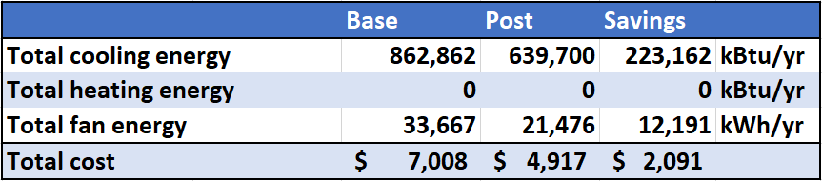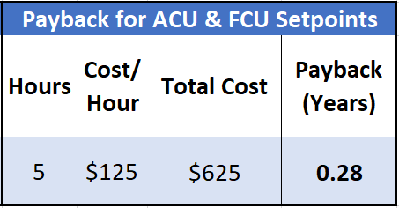
  - All Recommendations
The full savings and payback estimates assume that all recommendations are implemented. The savings are broken out by energy type and calculated for energy, cost, and carbon emissions. The total payback is less than eight months.
Table 17: Breakdown of Energy Savings
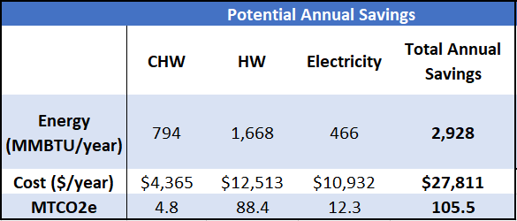
Table 18+19: Payback of All Measures and Baseline Energy and Costs vs. Post Case
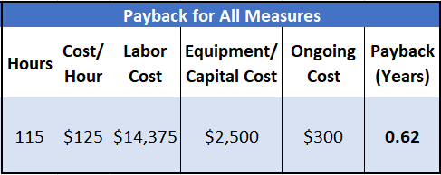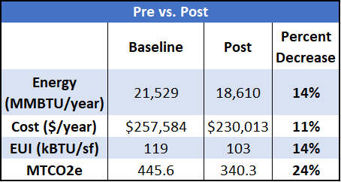
- LONG TERM RECOMMENDATIONS
After these recommendations are implemented, it is important to have some regular monitoring of the building energy. We recommend enlisting the Energy Conservation Office’s data analysis team to create monthly or quarterly energy models and compare them against the baseline. This will require fixing the CHW flow meter, but the team can use the points that are in the UC Davis PI database to perform the measurement and verification that is regularly performed for other buildings.
As mentioned in the results section, utilizing the Energy Conservation Office’s scheduling team to help schedule the AHUs and lights each quarter not only helps save energy but could be expanded to other buildings without much work.
We do not think implementing a full fault detection and diagnostics software such as SkySpark in the building would be cost effective. Once the recommendations are implemented, regular energy modeling should be sufficient as an M&V strategy and should catch any major issues, and a program like SkySpark is probably more useful in a lab or critical space.
- FUTURE WORK
Sources of uncertainty include the modeling strategy for estimated AHU savings, the models created for determining the energy profile, the lighting energy density estimates, and the FCU/ACU setpoint change model. A future study could build more robust engineering models and physically investigate the building to reduce uncertainty in the savings estimates.
There were a few measures that we were unable to address, either due to time or physical limitations. Surveying every zone for its use and occupancy and recalculating both the required minimum flow for each VAV box and minimum outside air requirements for each AHU using ASHRAE 62.1 ventilation requirements could help reduce the required fan speed to properly ventilate the spaces and reduce heating and cooling of the mixed air to meet the DAT setpoint.
A physical light count could ensure that all of the lights in use, especially exterior lighting, are LEDs and that spaces are not getting more light than necessary. Installing LEDs or removing lights that are unnecessary for the use of the spaces should have very short payback periods.
Finally, evaluating the plug loads or other equipment in the building through a proper walk-through and utilizing loggers to understand any other sources of energy use could lead to measures such as scheduling the plug loads or making recommendations around equipment use. These may take a bit more time and could require capital investments, unlike most of the recommended measures, but could still result in relatively short payback periods.
- REFERENCES
[1] “Advanced Energy Retrofit Guide” https://www.nrel.gov/docs/fy14osti/60913.pdf. Accessed 22 Apr. 2020.

[2] White_paper_classrooms. https://www.krueger-hvac.com/files/white%20papers/white_paper_classrooms.pdf. Accessed 22 Apr. 2020.

[3] Mills, Evan. “Building Commissioning: A Golden Opportunity for Reducing Energy Costs and Greenhouse Gas Emissions in the United States.” Energy Efficiency, vol. 4, no. 2, May 2011, pp. 145–73. DOI.org (Crossref), doi:10.1007/s12053-011-9116-8

[4] Fumo, Nelson. “A Review on the Basics of Building Energy Estimation.” Renewable and Sustainable Energy Reviews, vol. 31, Mar. 2014, pp. 53–60. ScienceDirect, doi:10.1016/j.rser.2013.11.040.1

[5] S. T. Taylor, “Resetting Setpoints Using Trim & Respond Logic,” p. 6

[6] S.T. Taylor, “VAV System Static Pressure Setpoint Reset,” ASHRAE J., p. 9, 2007

[7] “Data Center Power Equipment Thermal Guidelines and Best Practices,” ASHRAE TC 9.9. 2016. https://tc0909.ashraetcs.org/documents/ASHRAE_TC0909_Power_White_Paper_22_June_2016_REVISED.pdf

