University of California, Davis

Final Report
Existing Building Electrification:
City of Sacramento

Ashley N. DePew, Keshwad Nayebi, Daniel Simpson
ABT 212 Path to Zero Net Energy
June 8, 2021

Introduction
California has been and remains to be a leader in environmental initiatives in the United States. Often on the cutting-edge of technological advancements and policies within the country, California has now set to be carbon neutral by 2045 as declared by California Executive Order B-55-18 (2018). Of the range of initiatives to decarbonize the built environment, building electrification is a prominent strategy. The Environmental and Energy Study Institute (EESI) defines beneficial electrification as “a term for replacing direct fossil fuel use (e.g., propane, heating oil, gasoline) with electricity in a way that reduces overall emissions and energy costs” (EESI, n.d.).
California’s capital, the City of Sacramento, is in the process of constructing a breakthrough new construction electrification ordinance to ensure all-electric buildings are established and responsibility is bound by municipal legislature (City of Sacramento, n.d.). To abide by this ordinance in the future, developers and contractors must cease implementing new natural gas connections and subsequently install all-electric appliances within their buildings. However, the overwhelming majority of building stock annually is composed of existing buildings; existing buildings must be retrofitted to replace gas-powered appliances with their all-electric equivalents. As this equipment is not like-for-like in terms of processes of production of end use services (space and water heating, cooking), retrofits are often more involved and more complicated, given space constraints and infrastructure requirements.
The City of Sacramento has indicated that they intend to be a leader, not only for their own community members, but for surrounding communities and California as a whole. Therefore, the City of Sacramento has committed to electrify 25% of their existing municipally owned building stock of roughly 400 buildings by 2030. To accomplish this goal, the City tasked a team of students in the Pathway to Zero Net Energy course at University of California, Davis (hereafter known as the Electrification Team) to curate information on electrification benefits, policy, barriers, and best practices, as well as provide recommendations for retrofit strategy procurement. The level of detail of available data was insufficient for the Electrification Team to curate a comprehensive electrification strategy. This report intends to serve as a tool for existing building electrification strategy configuration.

Benefits of Electrification & Equity Considerations
Of the range of assets of electrification in California, prominent factors are emissions reduction, health and safety improvement, and utility bill savings.
The intention of electrification as a means to decarbonization is to reduce greenhouse gas emissions; studies have discussed that when combined with a clean grid (such as California’s fuel mix) and efficient end-use equipment, ceasing to burn fossil fuels onsite at buildings can achieve reduction targets (Dennis, 2015). In 2019, renewable energy produced 31.7% of California’s total system electric generation, large hydropower produced 14.62%, and nuclear energy produced 8.98% (CEC, n.d.-a). Given the relatively low carbon intensity of this mix, electrifying end-use appliances contributes to overall lower emissions instead of merely displacing emissions from the building sector to the generation sector via an increase in electricity demand once buildings are electrified. The U.S. Energy Information Administration’s (EIA) 2021 Annual Energy Outlook notes a projected reduction in U.S. carbon dioxide emissions within the current and next decades as the nation switches fuel mixes to a cleaner, more renewable- and gas-dependent grid in lieu of coal and fossil fuels in general (EIA, 2021).
Ceasing onsite natural gas combustion also boosts health and safety. Indoor air quality is negatively impacted by onsite fossil fuel combustion, such as that of gas-powered equipment for space heating, water heating, cooking, and clothes dryers (CARB, n.d.-a). For example, cooking on gas ranges produces nitrogen dioxide, which is pernicious and can have extreme negative health consequences if inhaled by children (Seals & Krasner, 2020). Among these consequences are cognitive disabilities, cardiovascular complications, and respiratory conditions such as destroying tissue antioxidant defenses, augmented infection vulnerability, aggravated pathways and symptoms, and asthma susceptibility (Seals & Krasner, 2020). Further, Nadeau et al. report in their study of groups in various California locations that groups with higher air pollution exposure have a higher risk of death resulting from asthma complications (2010). Asthma is an especially prevalent chronic disease in children (Nadeau et al., 2010); children are generally more sensitive to respiratory complications associated with air pollution due to underdeveloped respiratory and immune systems and defenses, large proportion of lung surface in proportion to their smaller bodies, and significant breathing rates and frequent exercise activities (Seals & Krasner, 2020). Retrofitting equipment for all current gas-consuming end-uses to all-electric counterparts can improve indoor air quality, thus mitigating some possible effects.
In addition to improved indoor air quality, all-electric buildings mitigate risk in emergency situations. In the event of a fire, first responders must locate utility shutoffs (Holmberg et al., 2013). The presence of gas lines in a burning building poses a large threat to both building occupants and first responders due to the potential for leakage and subsequent explosion. Additionally, natural events such as earthquakes, which are prevalent in California, can damage gas lines, prompting fire, explosion, and brisk sprawl of flames in hot, dry climates (ASCE-25 Task Committee on Earthquake Safety Issues for Gas Systems, 2002). Fully electrified buildings lack this added hazard imposed by gas systems and are unburdened by this concern.
A financial benefit associated with the operation of all-electric buildings is the possibility of lower utility bills. While electricity bills vary between utility and rate structure, SMUD has a range of commercial electricity rates which are 31.5% - 47.8% lower than those of Pacific Gas and Electric Company (PG&E), with an average of 34.7% lower (SMUD, n.d.-a).
An essential consideration in electrification planning is equity. Understanding where disadvantaged communities are and how electrification can serve them is fundamental to environmental justice; low-income and disadvantaged communities will be the last customers on the gas grid due to lack of resources to voluntarily electrify, stuck with high gas prices and cost of maintaining the aging gas grid, without intentional planning to ensure these communities to not unduly bear this burden (Miller et al., n.d.). In order to facilitate an equitable transition, choosing to electrify public-facing buildings - especially in disadvantaged communities - is paramount. Public-facing building electrification allows residents to directly reap the aforementioned benefits of electrification, by providing them with public spaces with safe all-electric infrastructure, clean indoor air, and places of reprieve with air conditioning and possible refuge in power outage events, if the building is equipped with onsite solar plus storage.

Policy Landscape
With the signature of Governor Brown in 2018, Assembly Bill 3232 (AB 3232) established the target of reducing building emissions (both residential and commercial) to 40% below 1990 emissions levels by 2030 (Delforge & Borgeson, 2018). This accelerated decarbonization strategies. However, electrification as a decarbonization tool was not mandated.
Industry stakeholders have expressed that the lack of top-down, state-level electrification policy is integral to achieving complete electrification (Outcault et al., forthcoming). One pathway to achieving a statewide policy is through Title 24. California’s Title 24 parts 6 and 11, the Building Energy Efficiency Standards, are amended by the California Energy Commission (CEC) in three-year cycles (n.d.-b). There is speculation about an electrification-favorable Title 24 in the 2022 code cycle, and an all-electric 2025 code, both for residential buildings (Outcault et al., forthcoming).
Because there lacks a blanket policy for statewide electrification, 46 cities across California have adopted gas bans or reach codes (Gough, 2021). These measures promote electrification via disallowing new gas connections in new construction (O’Hern, 2021). The City of Sacramento recently passed a new construction electrification ordinance, mandating that new buildings under three stories be built all-electric by 2023, and all new buildings be built all-electric by 2026.
New construction electrification initiatives are integral to phasing out natural gas use; however, upwards of 75% of California’s built environment was constructed prior to Title 24’s establishment (CARB, n.d.-b). While Title 24 requirements can be triggered by sizable renovations, a comprehensive existing building electrification retrofit strategy is imperative to accomplishing electrification goals within a municipality.

Barriers
There exist some challenges to be addressed regarding existing building electrification retrofits. First and foremost, electrical infrastructure must be sized appropriately to accommodate a larger electrical load. This includes building electrical panels, subsequent wiring, and grid transmission infrastructure (Outcault et al., forthcoming). Depending on the extent of the upgrade, electrical infrastructure retrofitting can be very expensive (Outcault et al., forthcoming). So, combining cost of equipment, cost of infrastructure upgrades, and labor expenses, whole-building retrofits are often difficult to complete at once, as they require a large upfront capital investment.
Aside from the infrastructure barriers, there is a shortage of skilled labor to install all-electric equipment and execute these retrofits. Outcault et al. note that this labor shortage is due to both lack of familiarity with the technology, as well as lack of willingness to learn; some contractors are hesitant or resistant to equipment such as heat pump installation, and thus will advertise steep, sometimes excessive, prices for all-electric technology that make gas counterparts much more attractive (forthcoming). A 2019 report from University of California, Los Angeles estimated that total electrification of both existing buildings and new construction by 2045 would require 100,000 construction industry workers and 4,900 manufacturing industry workers (Jones et al., 2019). Additionally, 12,400 employment opportunities in electricity generation and distribution would be produced, while up to 6,800 gas jobs would be lost (Jones et al., 2019).
Worker education (and subsequently customer education) can increase market adoption of all-electric technologies, which therefore can decrease price and required capital investment to make retrofitting existing buildings to all-electric more feasible (Outcault et al., forthcoming).

Electrification Retrofit Best Practices
Space Heating
The majority of commercial building end-uses are already fully electrified in the United States. The only uses still dominated by natural gas are space heating, and water heating with some specialty applications still dominated by natural cooking, and clothes drying (Deason et al., 2018).
Electrical heating systems are dominated by traditional resistance heaters and heat pumps. While resistance heaters are technically 100% efficient, heat pumps are able to produce two to five times the thermal energy with the same electrically input. These systems use the air temperature difference between ambient and treated air like a domestic air conditioning unit to adjust temperatures. The system is able to surpass greater than 100% efficiency as the system uses the electricity only for a fan and a pump, with an evaporation/condensation cycle producing the actual changes in temperature.
The EIA’s last Commercial Buildings Energy Consumption Survey (CBECS) is from 2012. While this data is nearly a decade old, until the 2018 version is released it still has the most comprehensive census data for commercial building energy trends in the United States. According to the CBECS commercial buildings in the United States consume over 5000 trillion Btu of natural gas annually (EIA, 2016). Reported consumption levels by end use are 1971 trillion Btu for space heating, 1771 trillion Btu for Water Heating, and 1,238 trillion Btu for Cooking (EIA, 2016). Among California commercial buildings, space heating and water heating are responsible for approximately 70 percent of all on-site fuel combustion (Hopkins et al., 2018).
CBECS national report data is divided by region. California falls into the Pacific region along with Washington and Oregon. Pacific region space heating breakdown shows package units compose 53.7 percent of commercial systems (EIA, 2016). These forced air hybrid systems contain a natural gas element for air heating and an electric air conditioner for cooling. These systems are coupled with ducted air systems and often come in the form of a rooftop unit (RTU) commonly called a “gas-pack” (TRC, 2016).
The second most common system, holding 19.7 percent of the market in the pacific region, is individual space heating (EIA, 2016). These systems are most commonly either natural gas, common in large commercial spaces like loading docks, or the traditional baseboard electric resistance systems common in small office buildings. Heat pumps are the third most common in this region holding 11.6 percent of the market. Furnaces and Boiler heating systems together hold only 14.4 percent of heating systems (EIA, 2016). A 2014 California Commercial Saturation Survey prepared for the California Public Utilities Commission (CPUC) reported that only 20 percent of commercial buildings in Northern California have electric space heating, while that number increases to 40 and 57 percent in the Los Angeles and San Diego areas, respectively. The survey also reports that these systems are 85+ percent ducted heat pumps (Itron Inc., 2014).
This data is encouraging for electrification efforts as furnace and boiler systems tend to be the most complex and expensive to retrofit (SCE, 2020b). Package units and RTUs in particular generally involve the least demolition, infrastructural costs, and incremental retrofitting costs overall (Hopkins et al., 2018). If these systems alone were universally converted to heat pump units, the Pacific region could reach over 60% heating system electrification. In California natural gas is still the dominant heating fuel in commercial buildings in Northern California, but buildings are around 50 percent electrically heated in the Los Angeles area, and in the San Diego area all-electric heating is more common than natural gas-heated buildings (Hopkins et al., 2018).
Based on this data, the City of Sacramento can expect to encounter mostly package units when it audits its commercial buildings portfolio. The most direct and easily recommended retrofitting is replacing RTU gas-packs with heat pump package units. The majority of these systems are designed and sized to fit directly onto the footprint of a comparable capacity gas-pack (Group 14 Engineering, 2020). These system replacements require some electrical infrastructure upgrades and gas system disconnections, but generally involve the least infrastructural adjustment and building demolition.
Because the program budget has not yet been defined, estimates of cost and what could be considered “low-hanging fruit” would be the most helpful for proving project viability to less enthusiastic stakeholders, and focusing on these heat pump RTU retrofits is a recommended electrification retrofit first step.
For individual space heating retrofitting, recommendations become more complicated. In the absence of a duct system, heat pump split systems are often the most direct fit. Mini-split systems can be sized and installed for a variety of spaces with minimal demolition or electrical upgrading to a ductless space (TRC, 2016). Alternatively, upgrading to a central electrification system such as a variable refrigerant flow (VRF) can reduce the number of units and system footprint while adding to system efficiency and demand response capabilities (SCE, 2017). This kind of upgrade will require more infrastructural changes and include more upfront costs, but can lead to life-time savings for some applications (Minezaki et al., 2020). If there is a ducted air conditioning system serving the building, it is recommended that both systems be replaced with a packaged heat pump system if the building's infrastructure allows. Research indicates that the lifetime incremental cost of a heating system retrofit is significantly better when the retrofit includes heating and air conditioning replacement with a package unit (RMI, 2019). If single zone heating is coupled with a single zone ducted cooling system, then it is recommended that heating and cooling be retrofitted with a packaged single zone heat pump system (TRC, 2016).
Furnace heating systems use air circulated through duct systems and are found in some small commercial buildings. In California, these systems are often coupled with a central air conditioning system. Costs and conditions can vary greatly, but this should be seen as another chance to replace both systems with split or packaged ducted heat pumps depending on the existing system design (Nadel & Perry, 2020).
Replacing an existing central boiler heating system in a larger commercial building can be complicated and retrofitters should consider air-to-water or water-to-water heat pump systems as well as VRF system options (Group 14 Engineering, 2020). Variable refrigerant flow systems are recommended over heat pump Air-to-Water boilers for most multi zone ductless applications (Minezaki et al., 2020). Their increased initial investment is compensated for by life-time savings, especially when coupled with a dedicated outdoor air system (Minezaki et al., 2020).
VRF systems pipe heat or cool refrigerant to fan coils throughout a building much like a traditional boiler system, and can be a good fit for replacing ductless systems. These systems can be designed to include dedicated outdoor air systems (DOAS) which significantly increases energy savings and economics of a VRF system, but also increases the upfront costs (NEEA, 2020). Research has shown that DOAS can be a key to reducing energy usage in commercial all-electric buildings (Minezaki et al., 2020). The majority of nonresidential net-zero energy projects in California include DOAS, and they are becoming increasingly popular internationally due to the flexibility they offer designers and owners. A decoupled DOAS allows VRF systems to cycle off when not in use, and can save energy by providing ventilation heat recovery (Minezaki et al., 2020).
Southern California Edison’s emerging products group conducted research on the use of VRF systems in office spaces in Mission Viejo, CA. The one-year study showed a total VRF energy use was 7.6 kWh/sq. foot/year. The system was able to achieve a 35 percent reduction during demand response events and showed more precise space conditioning than the system it replaced (SCE, 2017).
If an air-to-water heat pump (ATWHP) boiler is determined to be the best choice to serve an existing variable air volume system, the hot water coils in reheat boxes will need to be upsized (TRC, 2016). Current heat pump boilers cannot provide water at traditional boiler design temperatures, and coil surface area must be increased for comparable performance (TRC, 2016).
EnergySTAR awarded ATWHPs the Emerging Technology Award for 2019(EnergySTAR, 2020). Numerous commercial applications show ATWHPs have advantages over traditional hydronic systems in existing buildings (Siegenthaler, 2018). An ATWHP system can provide zoned heating using existing radiant panels, and zoned cooling/dehumidification using small air handlers (Siegenthaler, 2018). Compared to a typical gas condensing boiler system, ATWHPs offer energy savings up to 47 percent with a seasonal Coefficient of Performance (COP) of 1.7 - 3.0. Adding a storage tank to an ATWHP system can allow buildings to couple efficient domestic water heating. These systems use hot water to deliver heat, so they can often be retrofitted to provide heating and cooling in hydronically-heated buildings with less demolition and infrastructural changes than other options (EnergySTAR, 2020). It should be noted that with maximum low temperatures in Sacramento reaching only 5° C, some research shows that air-to-air heat pumps will perform more efficiently than their ATWHP counterparts (Biao, 2019).
The Electrification Team recommends that all retrofits use the highest efficiency equipment currently available. This is the recommendation of the California Energy Commissions 2021 Building Decarbonization Report, which estimates that total state building energy demand can be reduced by 19 percent if these technologies are used for retrofit and new construction building electrification (CEC, 2021). It can also be anticipated that California regulatory agencies will continue to advance building codes to match advancing technologies. Additionally, the Sacramento Municipal Utility District (SMUD) 2020 Integrated Design Solutions Incentive (IDS) Program has incrementally higher incentives for higher efficiency systems (CEC, 2021).

Domestic Hot Water
For all domestic hot water system sizes, heat pump water heaters (HPWH) have been shown to be 49-63 percent more energy efficient than a traditional resistance electrical water heater (Sparn & Hudon, 2011). Research has also shown that the HPWHs are effective at both reducing bills and emissions over a natural gas system with thermal storage (Hong & Howarth, 2015). In their research report, Hong and Haworth stated that total emissions due to the running of a HPWH on electricity produced entirely by a coal fired plant had less global warming potential (GWP) than that of a natural gas hot water storage system at 20 and 100 years (2015). This data implies that the impact of California’s over 30 percent renewable grid will have an even greater reduction in GWP. The Hong and Howarth report’s analysis indicates that the GWP impact of water heating with natural gas from shale is six times that of a HPWH within the first year of operation (2015). This only drops to five times the GWP through a system's twenty years of expected life (Hong & Howarth, 2015).
According to Southern California Edison (SCE), infrastructural requirements to replace a commercial gas storage water heater with a HPWH are generally minimal. The system switch often requires only to cap the existing gas line, demolish the existing vent, and connect the new HPWH to the electrical system (SCE, 2020a).

Demand Response
Substantial research is currently being conducted to quantify the capabilities and enable the implementation of distributed demand response on California’s electrical grid. Smart, or flexible, electric heating and cooling options can help shift loads to take advantage of renewable generation during daylight hours. These technologies could soon become standard as California seeks to increase the number of renewables on the grid.
The use of electric space heaters with internal thermal storage have been used in many regions of Europe and the UK for decades (Heinen et al., 2018). Referred to as “storage heaters”, the technology uses resistance heating, insulation, and variable speed fans to release heat on a 24-hour cycle. The technology helps end-users shift electricity consumption and charging based on market pricing. Newer smart electrical thermal storage (SETS) is being deployed throughout the EU allowing consumers to engage in coordinated grid level demand response efforts. (Heinen et al., 2018) The Horizon 2020 RealValue project installed SETS in 1250 homes in Latvia, Ireland and Germany starting in 2015. This project collected data for three years on the economic and consumer impacts, and results showed decentralized smart electric thermal storage systems successfully linking to the energy markets (Heinen et al., 2018).
A Rocky Mountain Institute report modeled 15-year net present costs for standard and flexible use heat pumps in Oakland, California using current California electric rates, as well as a scenario in which peak system rates were three times higher than off peak. Only in the last scenario did the added cost of the flexible heating equipment reduce lifetime cost. In all cases, the cost of a natural gas heating system replaced at end-of-life was over $4000 less if it was not accompanied by an air conditioning system replacement (RMI, 2019).
The report shows strategic preheating or precooling spaces and the preheating of water shows savings of around $1,000 in lifetime energy costs compared with non-flex devices. The RMI reports that the current peak/off-peak pricing with a maximum 19% differential does not lead to enough savings to recover the cost of the flexibility control equipment (RMI, 2019). While this is not financially encouraging at the moment, an incentive program for these technologies was recommended in the CEC’s Building Decarbonization Report, and could manifest in the near future, along with a financial benefit program for participation in demand response events (CEC, 2021). The Electrification Team recommends that installed retrofit equipment be flexible or flex-capable wherever possible.
Cost
Building to building retrofitting costs will vary greatly based on the systems being replaced, the system that will work as a best fit replacement, and the infrastructural changes required to make the retrofit. The City of Sacramento indicated that the Electrification Team’s recommendations are for first steps, and because the program budget has not yet been defined, estimates of cost and what could be considered “low-hanging fruit” would be helpful for proving project viability to less enthusiastic stakeholders. This report gathered research from California and the United States to make high-level estimates that can assist the City of Sacramento in targeting its first steps action plan.
Analysis of packaged systems, furnaces, boilers, and space heaters shows that with current technology, no additional building efficiency work, and no carbon pricing or incentives, about 27 percent of national commercial floor space heated with fossil fuel systems could be electrified with a simple payback period of less than 10 years (Nadel & Perry, 2020).
The Palo Alto: Existing Buildings Summary 2016 report from consulting firm TRC looked at and analyzed low-rise small and medium office buildings using Title 24 compliance simulation software. The data may not be accurate for other building types or spaces that have higher hot water and space heating demands. The report modeled cost estimates for single zone 2-ton ducted heat pump systems for the small office (5,500 sf), and an ATWHP boiler system for the medium office (53,600 SF) (TRC, 2016). Its medium office analysis also included quotes for a VRF system (TRC, 2016).
The report included a gas disconnection fee of $1,433, varying labor and material costs, and circuit upgrades for the small and medium buildings of $880 per 2-ton unit and $4,381 respectively (TRC, 2016). Total system retrofit costs were reported at $10,670 for the small office with a $2,042 15-year energy cost savings over the natural gas system (TRC, 2016). The medium office total cost was estimated at $212,429 with a $42,227 15-year energy cost savings over the natural gas system (TRC, 2016). The VRF system retrofit was quoted at $689,000 (TRC, 2016). Incremental costs over like-for-like natural gas systems were reported at $1450 per 2-ton ducted single zone heat pump, and calculated at $1915 per ton for the ATWHP boiler with 110-ton capacity including the system and upsizing existing reheat box coils (TRC, 2016). Median installed incremental costs for ductless mini-splits was reported to be $1,730 per cooling ton, based on quotes solicited for a 2-ton single zone ductless system. (TRC, 2016)
SCE reported in 2020 the average infrastructural cost to install a high efficiency packaged HP to be $1559 all inclusive. The average infrastructural cost to a high efficiency split HP was $1810 all inclusive. The incremental Cost for retrofitting gas-pack RTUs with High efficiency Heat pump packaged units was $137 per ton. Incremental Cost of installing a high efficiency split-system heat pump of $467 per ton (SCE, 2020b).
Upfront costs for the electrification of furnaces in existing buildings can vary greatly. Hopkins et al. reported that replacing both the furnace and the air conditioning system with a packaged heat pump showed a cost $1500 below replacing both systems (2018). The same replacement when not including an existing air conditioning system at end of life led to a cost $900 higher than a like-for-like furnace replacement (Hopkins et al., 2018). California’s residential building combustion emissions fell 18 percent from 2000 to 2016; over the same period combustion emissions from commercial buildings rose by nine percent (Hopkins et al., 2018).
A commercial electrification study conducted on a 28,000 square foot (sf) office building in Lakewood Colorado gathered data from several contractors to estimate an RTU electrification retrofit cost of $2400 to $2600 per ton of system capacity (Group 14 Engineering, 2020).
Median installed cost for VRF systems is reported to be $2,863 per ton (Bulger, 2019), while another estimate is that VRF system costs are $18 per square foot (Strecker et al. 2016).
TRC reported the incremental cost of a HPWH system sized for a medium office at $3,344 including a $1365 circuit upgrade, and $3,187 for the small office with the same electrical upgrades (TRC, 2016).
According to Southern California Edison, the infrastructural cost to replace a commercial gas storage water heater with a HPWH is $262.36 all inclusive (2020a). This figure includes the labor and materials to cap the existing gas line, demolish the existing vent, and connect the new HPWH to the grid including wiring and breaker box (SCE, 2020a).
A 2020 report conducted by the Cadmus Group for the nonprofit A Better City estimated costs for commercial building electrification in Boston Massachusetts. Reported costs for air source heat pumps are $3,900 or more per ton, $8,300 or more per ton for VRF systems, and $12,000 or more per ton for group source heat pumps (Pandey et al., 2020).
A study conducted by the Rocky Mountain Institute reported that customers with existing gas service have higher life-time costs for switching to electric systems than replacing like-for-like in Oakland, California because the energy savings is not high enough to fully pay back the difference (2019). This however does not account for incentive programs or carbon credits (RMI, 2019).
Based on the accumulated data from the above reports, estimated incremental cost of the system electrification retrofits studied above the cost of a like-for-like NG replacement system per ton of capacity are shown in Appendix A.
The data collected can be used to estimate the cost of some systems retrofits. In Appendix A, a Rheem 10-ton heat pump package RTU system retrofit cost is estimated. This helps to illustrate what proportion of cost can be anticipated for the system and required building changes for these system swaps.
Because the City of Sacramento is looking at system retrofits before end-of-life, quantification of the cost of the accelerated replacement is necessary. The California Public Utility Commission, in conjunction with Southern California Edison released an Accelerated Replacement Cost (ARC) equation in 2020 specifically to determine accelerated electrification retrofit costs (SCE, 2020b). The equation is shown in Figure 1.

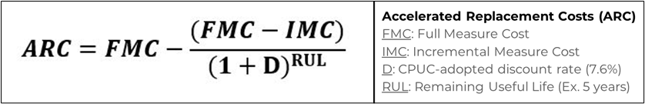
Figure 1: Accelerated Replacement Cost (ARC) equation.
Source: SCE, 2020b

Using the data from the electrification cost estimate shown in Appendix A, and assuming the replaced system has five years of remaining useful life, we can use the ARC to produce the accelerated replacement cost estimate, shown in Figure 2.
$$ARC=\$16,590-\frac{\left(\$16,590-\$140*10\right)}{{\left(1+.076\right)}^{5}}=\$6,060$$
Figure 2: Accelerated replacement cost estimate for modeled retrofit.
Sources: SCE, 2020b; TRC, 2016; Budget Heating & Air Conditioning Inc., n.d.

Incentives
To help encourage electrification, SMUD created the 2020 Integrated Design Solutions Incentive (IDS) Program. The incentive-based program is designed to help cover the incremental cost between efficient electrification equipment and standard replacements, and includes incentives for non-residential buildings. For some applications the program also has a “design team incentive” to support the design of innovative and cutting-edge energy efficient and electric technologies (SMUD Emerging Products Group, 2020).
The program’s electrification incentive offers $1 per square foot, up to a maximum of $25,000 for all-electric projects (SMUD Emerging Products Group, 2020). The program's backbone is the efficiency incentives which can be used in conjunction with the electrification incentives. These take the form of flat amounts for specific equipment. Incentives for HPWHs range from $1500 to $4000 depending on size. For space heating, incentives will only be rewarded for retrofitting spaces previously heated by natural gas. Mini-split incentives range from $300 to $1200, while larger systems are incentivized per ton of capacity. Packaged and split heat pump systems qualify for $500 to $550 per ton, while VRF system incentives range from $500 to $1000 per ton of capacity. Incentive values increase with both the size of the system and its efficiency, encouraging consumers to use the highest efficiency equipment possible. Water source heat pumps and other specialty equipment can qualify for incentives based on efficiency and electrical peak demand savings. The total incentive for any project is capped at $50,000 (SMUD Emerging Products Group, 2020).

Methods
The Electrification Team developed a list of possible municipal building targets (Appendix B) for the City of Sacramento, based on several methods deemed suitable for the initial phase of the City’s electrification initiative. First, the City expressed interest in targeting 25% of the City’s buildings with gas infrastructure, focusing on a total of 110 PG&E accounts. The Electrification Team was told that some of those facilities would require substantial demolition to electrify, so not all would be feasible targets.
Therefore, the Electrification Team employed the method of selecting buildings that are being updated via the EV Blueprint Grant, which was awarded to the City, to implement electric vehicle and bike charging stations throughout the City. This is due to the fact that these buildings will likely already be undergoing infrastructure upgrades, such as upsizing electrical panels and distribution networks. Thus, completely electrifying these sites would be optimal for cost effectiveness and efficiency. Also, these sites already tended to be public-facing buildings, which was a core factor in building selection.
Identifying building type and community area were paramount in the Electrification Team’s quest for equitable electrification planning. As discussed in the Benefits of Electrification & Equity Considerations section, it was imperative to identify public-facing buildings so that community members directly reap the benefits of electrification, which include safe all-electric infrastructure, clean indoor air, as well as places of reprieve with air conditioning during power outages if the City chooses to equip these buildings with onsite solar plus storage.
In order to accomplish this selection consideration, the Electrification Team focused mainly on community centers and libraries for building type. To pinpoint the community in which every site was located, the Electrification Team analyzed data from SMUD’s Sustainable Communities Resource Priorities Map, and color coded (from red to green) each site based on their sensitivity (red being the most sensitive and green being the least sensitive) (SMUD, n.d.-b). According to SMUD’s description on their website, the most sensitive “...indicate the local areas most likely to be underserved or in distress by lack of community development, income, housing, employment opportunities, transportation, medical treatment, nutrition, education and clean environment.”
The final list consisted of 28 sites, which makes up 25% of the City’s focused 110 PG&E accounts. To find these sites, the Electrification Team used a combination of the City’s internal database EnergyCAP, which included a number of important data points, such as natural gas use, and to some extent, electric use. EnergyCAP also included a number of reports, such as a customizable Ranking Report that provided data on annualized use (MMBtu), annualized use per area (MMBtu/SqFt), and current floor area (SqFt) for many of the sites. In addition, the City provided a number of other resources, such as an internal assessment report titled ‘2017 Facility Condition Assessment’ which included the build year of many sites, which was useful in understanding the potential condition of the building or facility (City of Sacramento, 2018). As seen in Appendix B, the “Communities Analysis” column color codes each site based on SMUD’s Sustainable Communities Resource Priorities Map disadvantaged identification color coding. Maps of each site roughly pinned on the Sustainable Communities Resource Priorities Map can be found in Appendix B.
Furthermore, direct collaboration with the City helped the Electrification Team understand what facilities managers and other department staff considered priorities, and where the focus should be when selecting target sites. A number of buildings on the list (highlighted in green: buildings 10, 11, and 12), were key opportunities identified by the City. While a number of other buildings (highlighted in red: building 26, 27, 28), were considered much more difficult to retrofit, yet critical nevertheless. For this reason, the Electrification Team determined that it would be more feasible to break these sites down by smaller units, to make it more convenient to retrofit, as is seen in breakdown under Pannell Community Center, for instance.
Lastly, the Electrification Team calculated an annual savings estimate (MMBtu) per building, as well as a total savings, based on the CEC’s modeled total energy demand reduction of 19% when using the most efficient equipment for electrification (CEC, 2021).

Recommendations
The pathway to 25% electrification is abstract and can take multiple forms. The Electrification Team’s recommendations identify the strategy of whole-building electrification, and retrofitting entire buildings with all-electric appliances. Therefore, once an individual building is completely electrified, it then and only then will count towards 25% of the entire building stock. To implement this strategy, city planners can identify buildings already undergoing infrastructure or appliance upgrades, or buildings with small and relatively simple retrofits for ease of completion. Also, phasing by use and location can take into account building occupant activities, namely public-facing buildings, dispersed throughout disadvantaged neighborhoods.
Alternatively, the City can define 25% similarly to SMUD’s recent efficiency measure of “avoided carbon”. In this approach, City planners can aggregate total building stock emissions across their portfolio, and reduce emissions by choosing to retrofit a specific end-use across all buildings, such as water heating or space conditioning.
For the immediate term, the Electrification Team recommends that city planners or commissioned consultants design electrification and efficiency retrofit plans for all buildings that will be electrified in the future. It is integral that plans for emergency equipment replacement be made. In the event of unexpected equipment failure, it’s critical that the necessary blueprint for how the space will be converted for the necessary all-electric appliance be formed in advance, as not to be stuck replacing like-for-like gas equipment on a whim’s notice, and subsequently tying the building to gas equipment for the foreseeable years.
Identifying and designating funding sources is a primary step, as different funding sources may facilitate or stipulate specific strategy practices. In terms of funding sources, this could include the City Budget itself. Additionally, the City can utilize aforementioned SMUD incentive programs. At the federal level, the Biden Administration’s decarbonization efforts could also provide necessary funding and support (The White House, 2021).
All things considered, we recommend a pilot to identify buildings with easily retrofittable rooftop package units, as this is highly cost effective and requires minimal demolition, with a focus on disadvantaged communities.

References
ASCE-25 Task Committee On Earthquake Safety Issues For Gas Systems. Improving Natural Gas Safety in Earthquakes. 11 July 2002, mitigation.eeri.org/files/CSSC_2002-03_Natural_Gas_Safety.pdf.
Budget Heating & Air Conditioning Inc. n.d. “Budget Heating & Air Conditioning Inc.” Budget Heating & Air Conditioning Inc. 813-885-7999 Factory Direct Pricing To The Public, www.budgetheating.com/.
Bulger, N. 2019. Economic Analysis of Heat Recovery Equipment in Commercial Dedicated Outside Air Systems. www.redcaranalytics.com/2019/06/19/economic-analysis-ofheat-recovery-equipment-in-commercial-dedicated-outside-air-systems/.
California Air Resources Board (CARB). n.d.-a. Indoor Air Pollutant Sources, ww2.arb.ca.gov/our-work/programs/indoor-air-quality/indoor-air-pollutant-sources.
California Air Resources Board (CARB). n.d.-b. Existing Buildings, ww2.arb.ca.gov/our-work/programs/building-decarbonization/existing-buildings.
California Executive Order B-55-18, 2018.
California Energy Commission (CEC). 2021. 2021 California Building Decarbonization Assessment. (Online) www.energy.ca.gov/data-reports/reports/building-decarbonization-assessment
California Energy Commission (CEC). n.d.-a. 2019 Total System Electric Generation. www.energy.ca.gov/data-reports/energy-almanac/california-electricity-data/2019-total-system-electric-generation.
California Energy Commission (CEC). n.d.-b. “Building Energy Efficiency Standards - Title 24.” California Energy Commission, California Energy Commission, www.energy.ca.gov/programs-and-topics/programs/building-energy-efficiency-standards.
City of Sacramento. 2018. 2017 Facility Condition Assessment.
City of Sacramento. n.d. Electrification of New Construction. www.cityofsacramento.org/Community-Development/Planning/Major-Projects/General-Plan/About-The-Project/Climate_Change/Electrification-Ordinance.
Deason, J., Wei, M., Leventis, G., Smith, S., Schwartz, L. 2018. LBNL Report Ernest Orlando Lawrence Berkeley National Laboratory Electrification of Buildings and Industry in the United States. Drivers, Barriers, Prospects, and Policy Approaches. http://eta-publications.lbl.gov/sites/default/files/electrification_of_buildings_and_industry_final_0.pdf.
Delforge, Pierre, and Merrian Borgeson. “Gov. Brown Signs Low-Carbon Buildings Bill AB 3232 into Law.” NRDC, 13 Sept. 2018, www.nrdc.org/experts/pierre-delforge/gov-jerry-brown-signs-low-emissions-buildings-bill-law.
Dennis, Keith. Environmentally Beneficial Electrification: Electricity as the End-Use Option. 1 Nov. 2015, www.sciencedirect.com/science/article/pii/S104061901500202X.
EnergySTAR. 2020. Air-to-Water Heat Pumps for the ENERGY STAR Emerging Technology Award for 2019.https://www.energystar.gov/about/awards/2019_Air-to-Water_Heat_Pumps
EnergyCAP. n.d. EnergyCAP Login, my.energycap.com/app/login.
Environmental and Energy Study Institute (EESI). n.d. Beneficial Electrification. www.eesi.org/electrification/be.
Gough, Matt. “California's Cities Lead the Way to a Gas-Free Future.” Sierra Club, 2 June 2021, www.sierraclub.org/articles/2021/06/californias-cities-lead-way-gas-free-future.
Group 14 Engineering. 2020. Electrification of Commercial and Residential Buildings: An evaluation of the system options, economics, and strategies to achieve electrification of buildings. Report for Community Energy Inc. www.communityenergyinc.com/wp-content/uploads/Building-Electrification-Study-Group14-2020.08.06.pdf
Heinen, S., Mancarella, P., O’Dwyer, C., O’Malley, M. 2018. Heat Electrification: The Latest Research in Europe. ieee power & energy magazine 16(June): 69–78.
Holmberg, David G., et al. Delivering Building Intelligence to First Responders. Feb. 2013, nvlpubs.nist.gov/nistpubs/TechnicalNotes/NIST.TN.1648.pdf.
Hopkins, A., Takahashi, K., Glick D., Whited, M. 2018 Decarbonization of heating energy use in California buildings: technology, markets, impacts, and policy solutions: Synapse Energy Economics Inc. October 2018. www.synapse-energy.com/sites/default/files/Decarbonization-Heating-CA-Buildings-17-092-1.pdf
Hong, B., Howarth, R. 2015. Greenhouse gas emissions from domestic hot water: heat pumps compared to most commonly used systems. Energy Science & Engineering. the Society of Chemical Industry and John Wiley & Sons Ltd. https://doi.org/10.1002/ese3.112
Itron Inc. 2014. California Commercial Saturation Survey: Prepared for the CPUC. August 2014. http://capabilities.itron.com/wo024/Docs/California%20Commercial%20Saturation%20Study_Report_Final.pdf
Jones, Betony, et al. California Building Decarbonization Workforce Needs and Recommendations. Nov. 2019, innovation.luskin.ucla.edu/wp-content/uploads/2019/11/California_Building_Decarbonization.pdf.
Miller, Camelita, et al. Equitable Building Electrification Framework. n.d. greenlining.org/wp-content/uploads/2019/10/Greenlining_EquitableElectrification_Report_2019_WEB.pdf.
Minezaki, T., Wang, S., Martin, E., Bulger, N. 2020. Codes and Standards Enhancement (CASE) Initiative 2022 California Energy Code: Nonresidential HVAC Controls. Prepared by Energy Solutions and Red Car Analytics. San Francisco: CPUC (California Public Utilities Commission). title24stakeholders.com/wp-content/uploads/2020/07/2022-T24-Draft-CASE-Report-HVAC-Control.pdf.
Mullen-Trento, S., Narayanamurthy, R., Johnson, B., Zhao, P. 2016 SMUD All-Electric Homes Deep Dive, Sacramento Municipal Utility District. 2016 2016/05/20
Nadeau, Kari, et al. “Ambient Air Pollution Impairs Regulatory T-Cell Function in Asthma.” The Journal of Allergy and Clinical Immunology, U.S. National Library of Medicine, Oct. 2010, pubmed.ncbi.nlm.nih.gov/20920773/.
Nadel, S., Perry, C. 2020. Electrifying Space Heating in Existing Commercial Buildings: Opportunities and Challenges. Washington, DC: American Council for an Energy-Efficient Economy. aceee.org/research-report/b2004.
Northwest Energy Efficiency Alliance (NEEA). 2020. Very High Efficiency Dedicated Outside Air System Pilot Project Report. Portland: NEEA. www.betterbricks.com/resources/vhedoas-pilot-project-summary-report.
O'Hern, Tess. “All-Electric REACH Code FAQ.” Community Environmental Council, 4 Feb. 2021, resource.cecsb.org/all-electric-reach-code-faq/.
Outcault, S., DePew, A., Akoda, Y., Meier, A. Forthcoming 2021. Residential electrification in Sacramento and its impact on appliance sales. Energy and Efficiency Institute Technical Report 2021-101
Pandey, A., Koo J., Torrie, Y. 2020. Thermal Electrification of Large Buildings in the Commonwealth. A Better City presentation. June 29, 2020. www.abettercity.org/assets/images/Theremal%20Electrification%20Presentation%206.29.2020.pdf
Rocky Mountain Institute (RMI). 2019. Rocky Mountain Institute The Impact of Fossil Fuels in Buildings: A Fact Base. https://rmi.org/insight/the-impact-of-fossil-fuels-in-buildings/.
Sacramento Municipal Utility District (SMUD) Emerging Products Group. 2020. 2020 Integrated Design Solutions Incentive Program Procedures Manual. https://www.smud.org/-/media/Documents/Business-Solutions-and-Rebates/Integrated-Design-Solutions-Procedure-Manual.ashx
Sacramento Municipal Utility District (SMUD). Business Rate Information, www.smud.org/en/Rate-Information/Business-rates.
Sacramento Municipal Utility District (SMUD). n.d.-b. “Sustainable Communities Resource Priorities Map.” Https://Usage.smud.org/SustainableCommunities/?_ga=2.265358157.312704329.1588887363-1871328095.1564615460# .
Seals, Brady, and Andee Krasner. “Gas Stoves: Health and Air Quality Impacts and Solutions.” RMI, 2020, rmi.org/insight/gas-stoves-pollution-health/.
Siegenthaler, J. 2018. “A Look at Air-to-Water Heat Pump Systems.” HPAC, May 31. www.hpacmag.com/features/air-to-water-heat-pump-systems/
Southern California Edison (SCE) Emerging Products Group. 2017. Testing of Commercial Variable Capacity Heat Pump ( VCHP ) for Small Commercial Office Buildings. https://www.dret-ca.com/wp-content/uploads/2020/08/Testing-of-Commercial-Variable-Capacity-Heat-Pump-VCHP-for-Small-Commercial-Office-Buildings.pdf.
Southern California Edison (SCE). 2020a. Workpaper SWWH027-01: Heat Pump Water Heater, Commercial – Fuel Substitution. San Francisco: CPUC. http://deeresources.net/workpapers
Southern California Edison (SCE). 2020b. Workpaper SWHC046-01: Heat Pump, Unitary Air Cooled HVAC, Commercial – Fuel Substitution. San Francisco: CPUC. http://deeresources.net/workpapers.
Sparn, B., Hudon, K., 2011. Results from Heat Pump Water Heater (HPWH) Laboratory Experiment. NREL Presentation: Second Annual Residential Energy Efficiency Technical Update Meeting. www1.eere.energy.gov/buildings/publications/pdfs/building_america/ns/eemtg082011_c18_hpwh_lab_experiment.pdf
Strecker, C., Iplikci, J., Crayne, M. 2016. Utility Program Cost Effectiveness of Variable Refrigerant Flow Systems. Proceedings of the 2016 ACEEE Summer Study on Energy Efficiency in Buildings 3: 1–12. Washington, DC: ACEEE. www.aceee.org/files/proceedings/2016/data/papers/3_345.pdf.
The White House. “FACT SHEET: President Biden Sets 2030 Greenhouse Gas Pollution Reduction Target Aimed at Creating Good-Paying Union Jobs and Securing U.S. Leadership on Clean Energy Technologies.” The White House, The United States Government, 22 Apr. 2021, www.whitehouse.gov/briefing-room/statements-releases/2021/04/22/fact-sheet-president-biden-sets-2030-greenhouse-gas-pollution-reduction-target-aimed-at-creating-good-paying-union-jobs-and-securing-u-s-leadership-on-clean-energy-technologies/.
TRC. 2016. Palo Alto Electrification Final Report. (Online) www.cityofpaloalto.org/files/assets/public/development-services/advisory-groups/electrification-task-force/palo-alto-electrification-study-11162016.pdf
U.S. Energy Information Administration (EIA). “EIA’s AEO2021 Shows U.S. Energy-Related CO2 Emissions Rising after the Mid-2030s.” EIA's AEO2021 Shows U.S. Energy-Related CO2 Emissions Rising after the Mid-2030s - Today in Energy - U.S. Energy Information Administration (EIA), 11 Feb. 2021, www.eia.gov/todayinenergy/detail.php?id=46736#.
U.S. Energy Information Administration (EIA). 2016. Commercial Building Energy Consumption Survey: 2012 CBECS Survey. (Online) www.eia.gov/consumption/commercial/data/2012/
Xiao, B., He, L., Zhang, S., Kong, T., Hu, B., Wang, R. 2019. Comparison and analysis on air-to-air and air-to-water heat pump heating systems. Renewable Energy. 146, 1888-1896 https://doi.org/10.1016/j.renene.2019.08.033

Appendix A
Best practices cost figures.

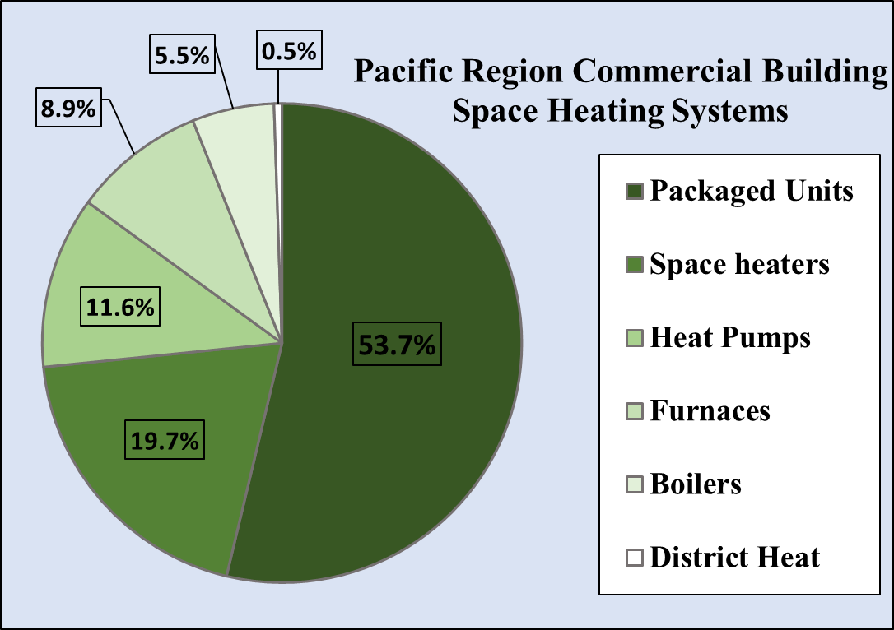
Figure 3: Pacific Region Commercial Building Space Heating Systems by type.
Source: EIA, 2016

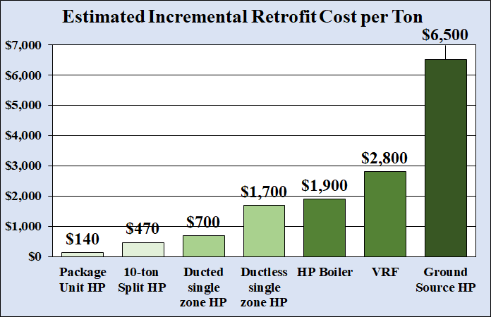
Figure 4: Incremental Cost over like-for-like NG system estimate based on gathered data.
Sources: Bulger, 2019; Pandey et al., 2020; SCE, 2020b; TRC, 2016

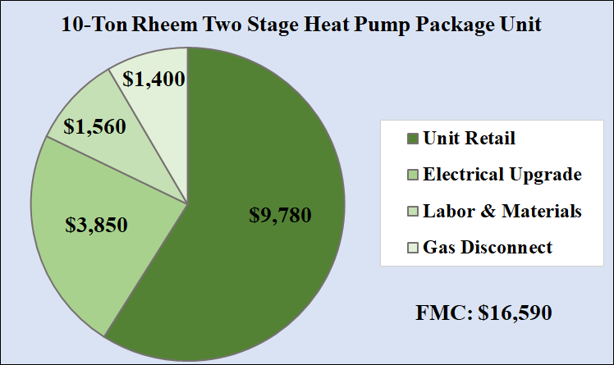
Figure 5: Example of estimated retrofit costs for a RTU based on collected data.
Sources: SCE, 2020b; TRC, 2016; Budget Heating & Air Conditioning Inc., n.d.

Appendix B
Public-facing buildings selection and disadvantaged communities mapping.

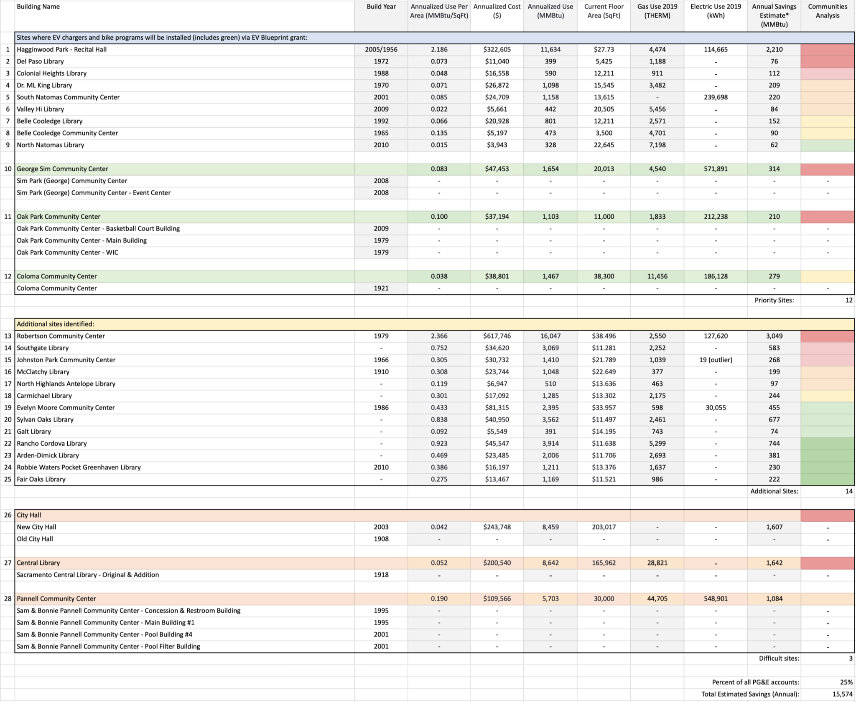
Figure 6: Prioritized public-facing buildings. Building characteristics, including disadvantaged labeling (“Communities Analysis” column) are included.
Source: EnergyCAP, n.d.; SMUD, n.d.-b

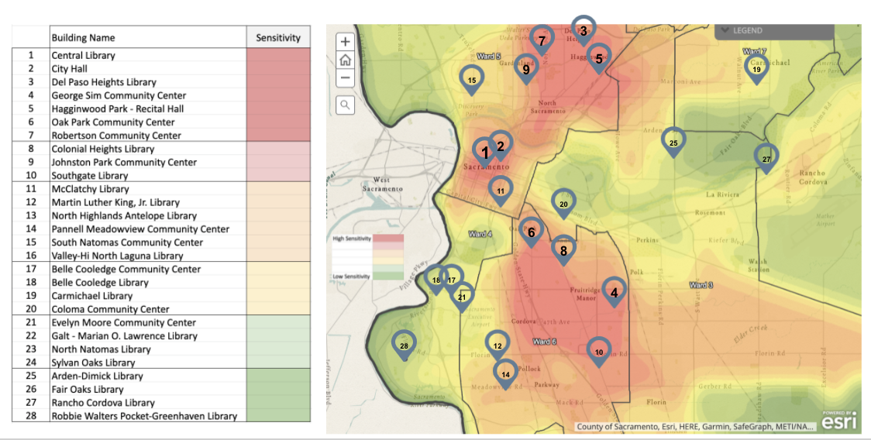
Figure 7: Identified buildings for retrofit numbered (left) and roughly mapped on the Sustainable Communities Resource Priorities Map (right).
Source: EnergyCAP, n.d.; SMUD, n.d.-b

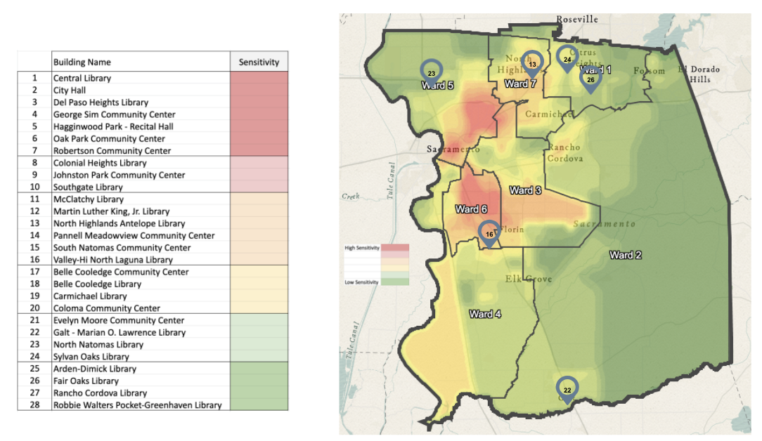
Figure 8: Zoomed out map of identified buildings for retrofit numbered (left) and roughly mapped on the Sustainable Communities Resource Priorities Map (right) to show chosen buildings further from the City’s core. Included buildings were chosen in 6 of the 7 identified wards.
Source: EnergyCAP, n.d.; SMUD, n.d.-b

Electricity rates vary across utilities and geography; for purposes of this report and its applicability to the City of Sacramento, the Electrification Team assumes electrification in Sacramento Municipal Utility District (SMUD) service territory.
https://usage.smud.org/SustainableCommunities/?_ga=2.265358157.312704329.1588887363-1871328095.1564615460#

