SpringBoard BioPro
Biodiesel Production Feasibility Study at UC Davis
Rujuta Munshi, Xiange Wang, Imby Abath
June 9, 2020

Background
Biodiesel is a clean diesel fuel derived from plants or animals and has significant environmental benefits over diesel. However, it has not yet been in wide use due to a lack of infrastructure and policies. The project goal is to perform a neutral feasibility study for Springboard Biodiesel and determine the financial and environmental benefits to implement an oil to biodiesel converter on the UC Davis campus. The client for this project, Springboard biodiesel’s president Matthew Roberts, wishes to obtain an objective analysis on the feasibility of their product to be implemented on UC Davis’ campus.

1.1 Biodiesel
Biodiesel is the only alternative fuel that passes the U.S. Environmental Protection Agency (EPA) Clean Air Act Tier I and II testing for health effects (Traviss). A B20 blend (20% biodiesel, 80% petroleum diesel) reduces work area respirable particles, PM2.5 (PM ≤2.5 µm in aerodynamic diameter), and formaldehyde levels compared with petroleum diesel (Traviss). It is also the optimal blend considering tradeoffs between increased NOx emissions and reduced smoke density, determined by comparing “exhaust emissions (smoke density, NOx, CO, and HC), the brake specific fuel consumption rate, the specific energy consumption rate, and the brake power and torque … under different engine loads and speeds” (Song).

A biodiesel heavy blend results in more lubrication within the engine and cleans out the engine, causing a filter change after a few runs, since the soot accumulated in a petroleum diesel running engine would be cleaned out by the biodiesel. This lubrication property helps extend the life of the engine itself, by reducing the impact from cyclical loads. It is important to prioritize switching older engines to biodiesel since newer diesel engines run cleaner and thus the biggest impact can be made by using biodiesel in the older engines.

Other facts worth noting about biodiesel include that the temperature of biodiesel exhaust is higher, with the possibility for higher cetane to decrease the exhaust temperature. Despite a lower smoke density, there is an increase of NOx emissions with biodiesel, which could be decreased by reducing the cetane number, highlighting that NOx emissions and exhaust temperature are inversely related so a balance must be found based on the scenario (Song). At first glance, it seems that confined places would be a good choice for biodiesel since there would be a decrease of compounds that pose a risk to people’s respiratory system, and the flashpoint of biodiesel is higher than petroleum diesel, reducing the chance of it sparking. This information can be used to recommend where diesel should be switched out for biodiesel first (Traviss).

1.2 BioPro 190 (Imby)
Springboard Biodiesel is the producer of the biodiesel processor named BioPro 190. This biodiesel processor is a machine that converts oil to alternative diesel fuel. This biodiesel process can contain a capacity of 50 gallons. It has a total cost of $12,250, excluding shipping fees. The 50-gallon cart costs $2,195, excluding shipping fees. According to Springboard Biodiesel, this biodiesel processor has an estimated life expectancy of 20 years. Springboard Biodiesel also offers a one-year warranty for every system purchased.

The conversion process for the oil to biodiesel has been broken down into ten segments to assist with understanding. In the conversion process, there are two reaction periods as well.

The first three steps of the process addresses the base catalyst and methanol conversion.
- Fill the main components of the TIG welded 304 stainless steel tanks up to the large “fill line” with filtered dewatered feedstock
- Add a predetermined amount of base catalyst and methanol to two other compartments
  - Base catalyst options include:
    - Sodium hydroxide or potassium hydroxide
    - Can be bought in premeasured doses
  - Methanol:
    - It is poured into the proper labeled ports
- Then measure a small amount of acid catalyst, press start and pour the acid into respective port
The next two steps addresses the two reactions that converts the oil to biodiesel.

- Reaction 1: Acid Catalyzed Esterification
  - The methanol is used to react with the free fatty acids present in the feedstock.
  - The sulfuric acid serves as a catalyst for this reaction.
  - The reaction is aided by thermostatically controlled heating and vigorous agitation via a stainless propeller
  - The acid catalyzation allows for a wide range of feedstock to be accommodated
- Reaction 2: Base Catalyzed Transesterification
  - The conversion of feedstock to biodiesel
  - The methanol/base catalyst solution from previously is metered into the feedstock
  - Large oil molecules are converted into three smaller biodiesel molecules
  - Oil molecules get replaced by three methanol molecules
  - The displaced atoms form a glycerol molecule

The settling period addresses the glycerol result from reaction 2.

- Settling period
  - The glycerol molecules formed in reaction 2 settle at the bottom of the tank
  - Biodiesel later is clearly separated above the glycerin phase
- Midpoint-glycerin phase removal-this is 24 hours later
  - The settled glycerin is drained by the users
  - Only user interaction needed-takes approximately - 5-10 minutes
The next phase consists of three washing phases.

- Washing cycle:
  - This process removes traces of glycerin, soaps, salts, methanol and other contaminants still in the raw biodiesel
  - Washing cycle 1: Coarse Washing
    - Gentle spray of water for containments to settle at the bottom
    - BioPro pumps out the dirty water
    - A sensor distinguishes the difference between the dirty water and biodiesel
  - Washing cycle 2 &3:
    - BioPro pumps appropriate amount of water to tank, agitating the contents in the tank mixing the biodiesel and wash water
    - This allows the containments to settle at the bottom of the water
    - A third process is repeated to ensure there are no containments left

The final steps of the process include the drying and production of biodiesel.
- Drying: final step
  - Heating, agitation, and evacuation fan cause any remaining water to evaporate, leaving only biodiesel
- Ready to use:
  - This biodiesel is ready for engine use
  - Complies with ASTM D6751 for standard biodiesel fuel quality

Maintenance
The maintenance on the system differs depending on its needs. To ensure no buildup of undissolved solids in the main tank chamber, turn the premix motor on for 5 minutes then pump contents into the chamber into the main tank and repeat. Every 2 to 3 years with a 75% use or greater of BioPro replace both the methanol and methoxide dispensing system. This has an estimated cost of $221. Every 4 years replace water in pump/water out pump. This has an expected cost of water in pump $98 and expected water out pump is $179. Every 5 years gaskets in the water out assembly need replacement. This has an expected cost of $28 dollars. Lastly, every 10 to 12 years: replace main stir motor. This has an expected cost of $425.

1.3 Case Studies
The goal for the case study is to show how successful the product is among current users, who the users are, and how they are using the product. Ultimately, the case study results provide insights to optimize the adoption of the product at UC Davis. The method used to conduct the case study is reviewing the user's website, contacting the user by email and phone, and performing a general search through news and articles. The main source is coming from the Springboard website that listed all the users. Springboard’s CEO also provided contacts for additional details. The research process spanned 2 months and due to limited contact and resources, 23 out of the 150 users are investigated in depth.

While researching the users, we investigated basic usage, including the size of the user group, frequency of use, gallons produced, and the purpose of production. As shown in the pie chart, the main purpose for the equipment is for educational and instructional use (Appendix E). Especially in the higher education sector, products are used for a small group of students to supplement a course or a project, and the user groups are relatively small. A small fraction of institutional users used BioPro products for larger scale biodiesel production and used the produced biodiesel for farming equipment and fleet vehicles. Thus, overall, institutions tend to use BioPro for teaching purposes.

Another major group of BioPro users are municipalities and farms. Although these two categories do not consist of a large share of users, they tend to produce higher amounts of biodiesel in general. Municipals collect cooking oils from town residents and use them to fuel the fleet, while farms that produce sunflower oil use the product to produce biofuel for farming equipment. They produce around 1000 gallons of biodiesel as reported.

The closest cases to UC Davis campus are Truman State University and Culinary Institute of CA- St. Helena, where Truman State produces 1000 gallons of biodiesel per year and CIA used the biodiesel for their campus shuttle. Truman State also obtains the cooking oil from on-campus dining halls and produces almost the same amount of biodiesel as UC Davis’ assumption of 1500 gallons per year. These two cases are similar to the UC campus situation and worth investigating further.

Overall, institutions or users with farming equipment tend to be more successful. The reason is that there is a large demand for biodiesel nearby and easy to implement and use the product. If there is not a large use of biodiesel near the BioPro equipment, the user is less likely to continue using the product for a longer time.

1.4 Competitive Landscape
A comparative analysis was also conducted to examine the different types of biodiesel processors available in the market. Alongside of Springboard Biodiesels’ BioPro 190, we examined the Biodiesel Kit Stores’ 40-Gallon processor and US freedom Biofuels’ BD65.
We examined the cost, capacity, conversation time, safety, ease of use, and preparation time.

Company | Product | Cost | Gallons | Time | Safety | Ease of use | Preparation time
Springboard Biodiesel | BioPro 190 | $12,250 | 50 | 48 hours | CE Mark | Automated system | 30 minutes
Biodiesel Kit Store | 40 Gallon Processor | $3,895 | 40 | 7-10 hours | Safety First Kit | Not Automated* | 30 minutes
US Freedom Biofuels | BD65 | $12,152.80 | 65 | 48 hours | -- | Not Automated | 15 minutes

In addition to the information on the BioPro 190 that have been listed above, there are several strengths and weaknesses to point out. In terms of strengths, this is an easy to use system because it is automated. Once the user inputs the proper ingredients the system does the conversion without interruption. The estimated time for this is 48 hours. It also has an automatic washing system. It is built with stainless steel such as Polyethylene to contain flammable liquids, and resist puncturing at high temperatures. It also bears a CE mark. This mark indicates that a conformity assessment has established that the machine complies with all the applicable safety, health, and environmental directives, allowing a customer to use the machine with confidence.
Weaknesses this system has are that the that the ingredients for prior preparation are sold separately. The listed prior preparation steps could be difficult for new users. The vaporization of methanol into the atmosphere is possible. It is also the most expensive biodiesel processor.

The 40 Gallon Processor from the biodiesel kit sore has a cost of $3,895. It is the least costly of all three systems. However, it can only contain 40 gallons for the conversion. This is the least amount of all three systems. This system has waterless washing system. This process takes on average 7-10 hours. This is the best time amongst the competitors. It also has an in-tank heating system. In terms of safety, the processor comes with a handsfree explosion proof methanol pump. It also has a safety-first kit for users. This consists of 2 different chemical resistant gloves, safety goggles, and dust masks. Lastly, it is the only system that provides the mixing ingredient for users.

This system does have a few weaknesses. It is a large system and not easily movable. Once it is installed in one location it must remain there. Assembly of the machinery must be done by a professional. It also is not automated. This requires for the user to return to the system at multiple times to ensure the conversion process is being done in each required time frame.

Lastly, the third system is the BD65 from US Freedom Biofuels. This system costs $10,952. It is able to convert 65 gallons every 48 hours. This puts it in front of the BioPro 190 in terms of timing. It has a dry wash system, which allows the cleaning process to be easy. The preparation time for ingredients is only 15 minutes. This is half the time of the other two processors. This system has a methanol recovery system. This allows the methanol to stored and possibly reused or redistributed.

This system seems to have the most weaknesses amongst its competitors. Similar to the 40-gallon processor, this is a large system and not easily movable. Once it is placed in an area it must remain there. Unfortunately, the data on the safety of the system was unavailable. This system is also not automated, which can serve as difficult for the user.

Methodology

2.1 Production Logistics
Based on the prior art and literature review, the steps for implementing biodiesel at UC Davis fall into 3 key stakeholders that need to be on board for the system to be run efficiently on campus.

- Source oil: The current source of used oil is UC Davis dining services. They have already worked to cut down waste oil by implementing a filtration system reducing total discarded oil by 32,590 gallons and recycling the 13,650 pounds they do use. This comes from a Filta report provided by UC Davis Dining Commons. While this waste oil is being converted to biodiesel off-campus, using the biodiesel on campus would reduce UC Davis’ carbon footprint. The company that is currently doing oil filtering and recycling is willing to take the oil to any location on campus, taking care of the oil transportation issue.
- Diesel User: To minimize the diesel transportation issue, the diesel should be converted at the same location it is being used. Since UC Davis has a lot of agriculture equipment running on diesel as well as utility vehicles such as garbage trucks there are many diesel users. Potential stakeholders to follow up with include Russel Ranch, the Student Farm, Utilities, and Unitrans. One of these diesel users would need to take charge of the operation and maintenance of the biodiesel production process.
- Waste Management: The final step is taking the waste glycerin/glycerol from the diesel production location to the anaerobic digester. Since UC Davis has an anaerobic digester on campus this trip can be made easily by the diesel user.

2.2 Waste Management
To optimize the impact of the biodiesel generation process, it’s important to ensure that the waste product of glycerin is not making it to landfills. The crude glycerol coming out from the converter has many possible uses.

One option is using glycerol as another energy source, creating a system in which the waste matter is a secondary input for generation. The low cost of glycerin and high hydrogen content make it a contender as a biofuel. This could be done with a pyrolysis method or in an anaerobic digester. Both refined and crude glycerin reached combustion after being converted to a hydrogen-rich syngas (Pickett). Another option is slowly inputting 5x diluted glycerol in an Anaerobic Digester. The hydrogen-rich properties allow glycerol to be used as a substrate for methane production in an anaerobic digester which creates thermal energy which creates heat or energy (Viana).

Another option which involves no infrastructure is using it in cow feed, when the glycerol is only 15% of the regular dry feed (Donkin). This is a disposal method that gives the glycerol a purpose rather than dumping it in the trash where it contributes to landfill waste. Another no infrastructure option is composting the glycerin, which is only biocompatible is the catalyst used is KOH.

A more involved method includes refining the glycerol and using it to create higher-value products, opening another stream of profits. Refined glycerol is a key ingredient in moisturizing products such as soaps, lotions, or hand sanitizers (Menegueti). With many departments here on campus, there is a potential use for creating or developing a high value product with waste glycerin and pursuing research with that.

3 Analysis

3.1 Cost Benefit

To understand the financial impacts of implementing this system, the costs for various inputs were found. Considering the product’s 20 year life span, the yearly costs of maintenance, and annual profits from just converting the Dining Services free used oil into biodiesel, the simple payback time and annual profits were determined, and a sensitivity analysis was performed comparing various used oil and diesel costs.
Assumptions made while calculating these costs are that the labor and space costs were assumed to be free. Since this system is automatic, it takes about 30 minutes of setup for each run and requires no specialized training to operate. The maintenance labor costs were neglected but the cost of parts was included, and a yearly estimate of $226.60 was made based on the conservative side of the replacement parts ranges (Appendix A).

The costs of the other inputs (besides electricity) can be scaled down for the 50-gallon converter but the electricity used is the same for each run. This means that the cost difference between two 50 gallon runs and one 100-gallon run differs by the cost of electricity for 1 run, which comes out to $2.07. Only one catalyst (either NaOH or KOH) is required, and since the cost of NaOH per run is greater, that was used for the cost per run calculations (Appendix B, E).

Exact numbers indicate that to convert all the cooking oil to biodiesel, 36.4 runs would be done throughout the year. For purposes of this analysis, we are rounding down to 30 runs per year, in order to make a more conservative estimate. The assumption of 30 runs per year, adjusts the maintenance cost of each run to $7.56, which would decrease with more runs.

Inputs for 100 gallons, those in dotted lines will be scaled down by ½ for a 50-gallon processor.

3.2 Sensitivity
The payback period is affected by the costs of all the inputs, and since the cost of diesel is always changing and the cost of oil will increase if the system expands to include oil outside of the UC Davis Dining services system these factors were analyzed further. Plugging in the costs of the inputs and developing a MATLAB script from this, allowed a visual representation of yearly profits for various oil and diesel costs for both the 50 gallon and 100-gallon processor. The script is set up to allow for easy changes when the cost of any input changes and can be modified to compare any two factors. Calculating the return on investment assuming a simple payback comes out to be 10.94 years when diesel prices are $1.50 per gallon, and 3.635 years when diesel prices are $3 per gallon (Appendix D).

The key takeaways from this study are seen in the image below: For a diesel cost of 1.5 the simple payback time is less than 11 years and increases steeply as the cost of oil increases. At this rate, oil purchased at 25 cents per gallon would result in a payback period over the lifespan of the device.

Meanwhile, with a diesel cost of 3 dollars, the simple payback time is less than 4 years and remains less than 5 years all long as used oil is purchased for under $0.75/gallon, before reaching a rapid increase payback period for prices greater than that. The steep vertical lines are a result of the data point going from infinity to a negative value. The point where these graphs cross the x-axis are points at which there is no profit being made from the product.
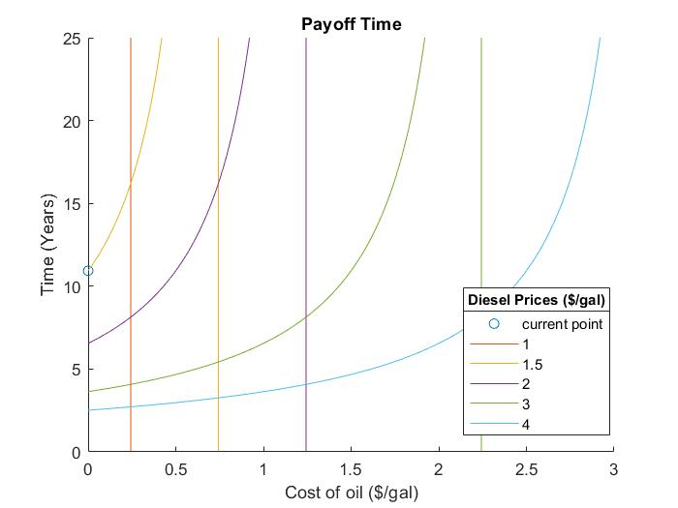

Russell Ranch has bought diesel recently at 1.50 per gallon, while usually purchasing it for $3/gal. This graph depicts the sensitivity of payback time as the cost of used oil and diesel varies. Additional Results are depicted in Appendix D.

3.3 Emissions

The purpose of the emissions analysis is to find the environmental impact biodiesel will bring to the user, especially to the UC Davis campus. The emission analysis is conducted in comparison to regular diesel and is calculated using literature data. The table below summarizes all the greenhouse gas emission reductions from biodiesel when compared to petroleum diesel.

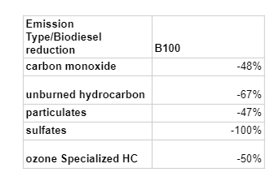

Based on the information and assumption of 1500 gallons of biodiesel produced each year, we can find the carbon monoxide reduction annually.
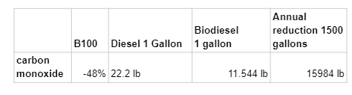
Overall, if UC Davis chooses to use 1500 gallons of biodiesel, it can save 15984 lbs. of carbon monoxide.

4. Results and Discussion
In terms of monetary benefits, generating biodiesel on campus is a good idea. The sensitivity analysis performed shows costs associated with biodiesel in comparison with diesel. When purchasing biodiesel, the cost is typically over 25 cents per gallon greater than petroleum diesel, and the 3-5 cents rebate doesn’t offset this (“Biodiesel.”). Making diesel in house eliminates the need for biodiesel certification processes.

A few sources of uncertainty include that the costs of diesel are constantly changing, and the quantity of oil from the dining services is a steady amount under regular operating conditions, but in the event that the filtering services is able to filter each batch of oil more times would impact the quantity of oil inputted into the converter. In order to accommodate for this, the possibility of needing to purchase oil should be considered, and the range of costs that result in a feasible payback period is associated with the cost of diesel.

Future includes reaching out to the Davis community and approaching food trucks and restaurants for their used oil. This increases the involvement of the point person in charge of the system and would in turn increase labor costs.

5. Recommendations and Conclusions
Our recommendations for UC Davis is based on the current sourced vegetable oil, is the BioPro 190. 30 50-gallon runs is only 22.7% of the processor’s annual capacity and is less than the diesel used by Russel Ranch in a one-year period, leaving ample room for growth. In the event that there is enough oil sourced, Springboard has an add on system available which would increase the turnaround time from 48 hours to 24 hours, doubling the systems overall capacity.

Before committing to the system, a complete life cycle analysis can be performed, validating that the system is beneficial to the environment, and the small batch biodiesel production is efficient enough to justify the use of the system. This will be done by comparing the resources involved in our proposed system with what is currently being done in Filta’s oil recycling program.

The necessities for the successful implementation of this system at any UC campus requires the following necessities.
- Inputs: Oil
  - Supply
  - Transportation to processor
- Biodiesel conversion and Use
  - Location for Bio Diesel processor
  - Stakeholder to maintain system
  - Diesel User
  - Diesel transportation
- Waste Management
  - Glycerol disposal method
  - Glycerol transportation

Here at Davis, we currently have the oil supply, transportation, and glycerol disposal determined.
Assuming the diesel user is our stakeholder to maintain the system, and the location of the processor eliminates the need to transport diesel (or one of the substances), these can be further simplified. While the environmental impact of this project when including the filter company and their biodiesel conversion process in the loop is neutral, when examining this system under the lens of UC Davis as an independent system, it decreases the carbon emissions while saving money in diesel costs. It also opens up additional avenues of research when looking at various biodiesels or uses of crude glycerin. Future work includes expanding the places oil is sourced from, such as local restaurants and food trucks. Ideally making people come to Davis to dispose of their used oil would be ideal, but a more likely option involves organizing used oil pickups.

Bibliography

“Biodiesel.” Alternative Fuels Data Center: Biodiesel, US Department of Energy,
afdc.energy.gov/fuels/biodiesel.html.
“BD65 Biodiesel Processor.” US Freedom Bio Fuels, usfreedombiofuels.com/bd65-biodiesel-processor/.
“Commercial Biodiesel Production Equipment - U.S. Freedom Bio Fuels.” US Freedom Bio Fuels, usfreedombiofuels.com/.
Donkin, Shawn S. “Glycerol from Biodiesel Production: the New Corn for Dairy Cattle.”
Revista Brasileira De Zootecnia, vol. 37, no. spe, 2008, pp. 280–286., doi:10.1590/s1516-35982008001300032.

Gonzalez-Garay, Andres, et al. “High-Value Propylene Glycol from Low-Value Biodiesel
Glycerol: A Techno-Economic and Environmental Assessment under Uncertainty.” ACS Sustainable Chemistry & Engineering, vol. 5, no. 7, 2017, pp. 5723–5732., doi:10.1021/acssuschemeng.7b00286.

Menegueti, Mayra Gonçalves, et al. “Glycerol Content within the WHO Ethanol-Based Handrub
Formulation: Balancing Tolerability with Antimicrobial Efficacy.” Antimicrobial Resistance & Infection Control, vol. 8, no. 1, 2019, doi:10.1186/s13756-019-0553-z.

Pickett, Derek, Christopher Depcik, and Susan Stagg-Williams. "Use of the Glycerin By-
product from Biodiesel Production for Power Generation." Journal of Engineering for Gas Turbines and Power 140.10 (2018): 1-1. Web.

Song, J-T, and C-H Zhang. "An Experimental Study on the Performance and
Exhaust Emissions of a Diesel Engine Fuelled with Soybean Oil Methyl Ester." Proceedings of the Institution of Mechanical Engineers 222 (2008): 2487-96. ProQuest. 22 Apr. 2020 .

Traviss, Nora et al. “Biodiesel versus diesel: a pilot study comparing exhaust exposures for
employees at a rural municipal facility.” Journal of the Air & Waste Management Association (1995) vol. 60,9 (2010): 1026-33. doi:10.3155/1047-3289.60.9.1026

Viana, M. B., et al. “Anaerobic Digestion of Crude Glycerol: a Review.” Environmental
Technology Reviews, vol. 1, no. 1, 2012, pp. 81–92., doi:10.1080/09593330.2012.692723.

Appendix

- Table 1: Maintenance Costs

Maintenance Costs |  |  | High End | Low End
Part | Time | Cost per part | $ / Year | $/ Year
Pump Replat | 2-5 year | 221 | 110.5 | 44.2
In/Out Pump | 4 years | 280 | 70 | 70
Gaskets | 5 years | 28 | 5.6 | 5.6
Main stir motor | 10 - 12 years | 425 | 42.5 | 35.41666667
Total |  |  | 228.6 | 155.2166667

- Table 2: Costs of inputs for a 50-gallon run
Input / Output | Quantity | Cost ($ / run) | Source
Oil | 50 gal | 0 | Dining Services
Methanol | 10 gal | 11.3 | American Chemical Supplies
Sulfuric Acid | 0.8 cups | 4.67 | Grainger
NaOH (98% purity) | 5.2 lbs | 10.40 | Spray Chem
KOH (90% purity) | 3.85 lbs | 10.01 | Spray Chem
Water | 45 gal | .18 | UCD
Electricity | 27kWh | 2.03 | UCD
Glycerol Disposal | 5 gal | .7 | UCD READ
Maintenance | Per Run | 10.35 | Springboard/ McMaster

Table 3: Economic Predictions

Metric | Diesel Cost $1.5/gal | Diesel Cost $3/gal | Equation
Net value / year | $1120 | $3370
Simple payback time | 10.94 years | 3.635 years | 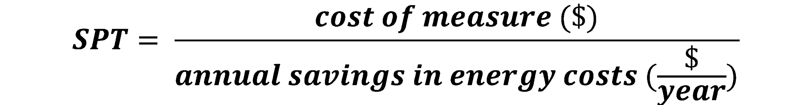

- Figures from Matlab Sensitivity Analysis

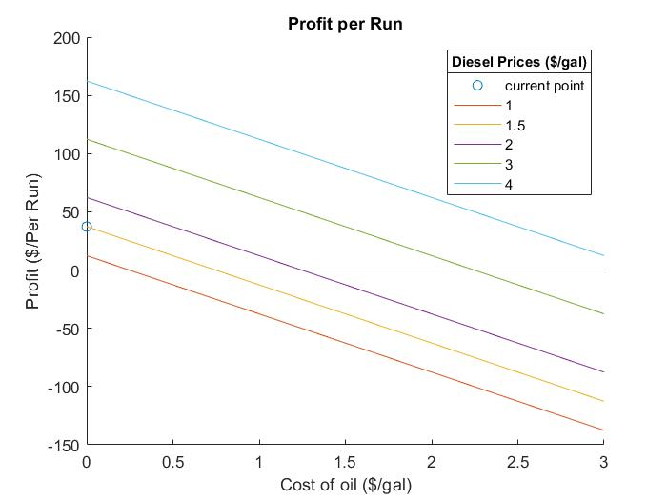  - Profit per 50-gallon run | - Profit per 100-gallon run
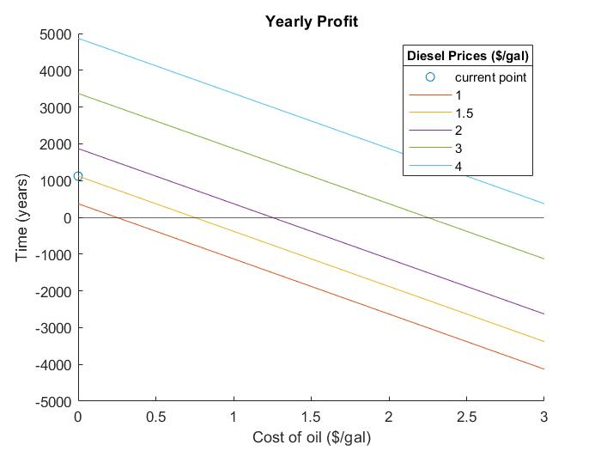  - Yearly Profit with BioPro 190 | 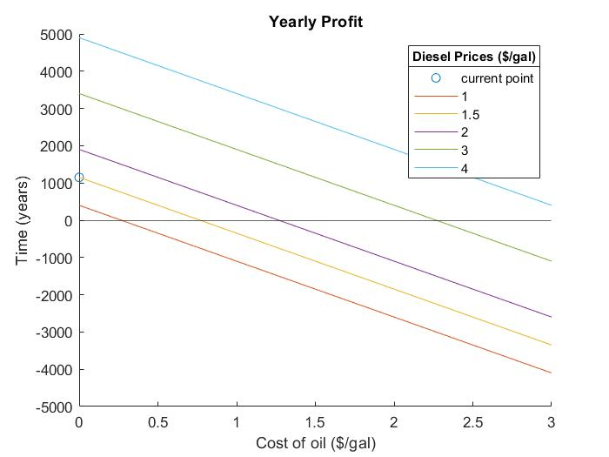  - Yearly Profit with BioPro 390
- Payback Time for BioPro 190 | 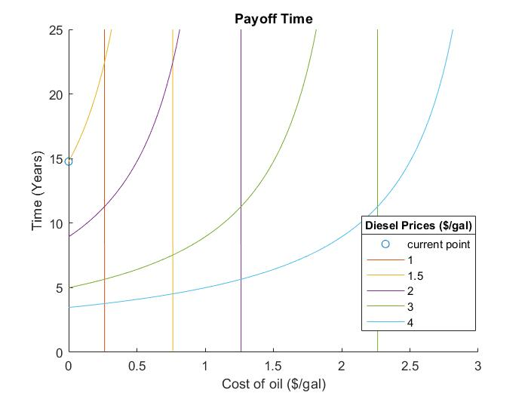  - Payback Time for BioPro 390

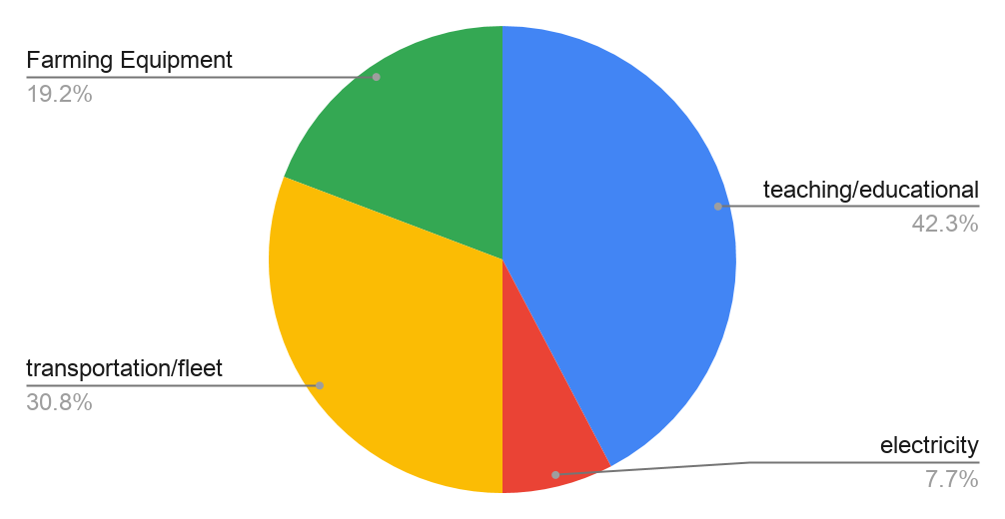
E.

F.
